**INTEGRATED HEALTH CARE APP**

**A PROJECT REPORT**

### Submitted by,

**S KIRAN KUMAR-20201CST0094**

**C NITISH KUMAR-20201CST0125**

**G SANTHOSH KUMAR-20201CST0143**

**M MUNI GOUTHAM-20201CST0156**

### Under the guidance of

**Dr. K SUSHEEL KUMAR**

### in partial fulfillment for the award of the degree of

**BACHELOR OF TECHNOLOGY IN**

**COMPUTER SCIENCE AND TECHNOLOGY**



**SCHOOL OF COMPUTER SCIENCE & ENGINEERING**

**PRESIDENCY UNIVERSITY, BANGALORE**

**JANUARY 2024**

**PRESIDENCY UNIVERSITY**

**SCHOOL OF COMPUTER SCIENCE ENGINEERING & INFORMATION SCIENCE**

**CERTIFICATE**

It seems like you're sharing a certification statement for a project report titled "**INTEGRATED HEALTH CARE APP**" submitted by the group "**GROUP-CST 24**" for the Bachelor of Technology degree in Computer Science Engineering with a specialization in Data Science. If there's anything specific you would like assistance with or if you have any questions, feel free to let me know!

**Dr. K Susheel Kumar** **Dr.Jayachandran Arumugam**

Asst. Professor HOD

School of CSE&IS School of CSE&IS

Presidency University Presidency University

|  |  |  |
| --- | --- | --- |
| **Dr. C. KALAIARASAN**  Associate Dean  School of CSE&IS  Presidency University | **Dr. SHAKKEERA L**  Associate Dean  School of CSE&IS  Presidency University | **Dr. SAMEERUDDIN KHAN** Dean  School of CSE&IS  Presidency University |

**PRESIDENCY UNIVERSITY**

**SCHOOL OF COMPUTER SCIENCE & ENGINEERING**

**DECLARATION**

Thank you for providing more details. It seems like you are affirming that the content in the project report titled "INTEGRATED HEALTH CARE APP," submitted for the partial fulfillment of the Bachelor of Technology degree in Computer Science and Technology (specialization in AIML) at Presidency University, Bangalore, is the result of independent research conducted under the supervision of Dr. K Susheel Kumar.

If you have any further information to add or if there's anything specific you would like assistance with, feel free to let me know.

|  |  |  |
| --- | --- | --- |
| **NAME** | **ROLL NUMBER** | **SIGNATURE** |
| S.KIRAN KUMAR | 20201CST0094 |  |
| C.NITHISH KUMAR | 20201CST0125 |  |
| G.SANTHOSH KUMAR | 20201CST0143 |  |
| M.MUNI GOUTHAM | 20201CST0156 |  |

**ABSTRACT**

The Integrated Health Care system proves to be a valuable resource for the general public seeking hospitals or doctors for consultations or medical procedures. The platform displays doctors and hospitals that provide diagnostic tests at regulated prices and maintain high-quality standards. Significantly, this free and customizable app serves as a tool for both patients and doctors to keep their information updated, creating a database to store profiles of medical professionals and patients alike. The android application's usability and effectiveness have been assessed, ensuring user-friendly features and customization options tailored to individual needs. The practical results indicate that the proposed application holds great promise for diverse users, aiding them in maintaining proper healthcare standards.

**ACKNOWLEDGEMENT**

We extend our sincere appreciation to Dr. Md. Sameeruddin Khan, the esteemed Dean of the School of Computer Science & Engineering at Presidency University, for facilitating the necessary permissions for our project.

Our heartfelt thanks go to our cherished Associate Dean, Dr. C. Kalaiarasan, and Professor Dr. K Susheel Kumar, the University Project-II In-charge at the School of Computer Science & Engineering, Presidency University, for their timely assistance, which greatly contributed to the successful completion of this project.

Special gratitude is conveyed to the University Project-II Coordinators: Mr. Mrutyunjaya MS, Mr. Sanjeev P Kaulgud, Mr. Rama Krishna K, and Dr. Madhusudhan MV.

We express our thanks to our families and friends for their unwavering support and inspiration, which played a crucial role in the successful realization of this project.

**S KIRAN KUMAR(20201CST0094)**

**C NITISH KUMAR(20201CST0125)**

**G SANTHOSH KUMAR(20201CST0143) M MUNI GOUTHAM(20201CST0156)**

|  |  |  |  |
| --- | --- | --- | --- |
|  |  |  |  |

**TABLE OF CONTENTS**

1. ININTRODUCTION 07
2. LITERATURE REVIEW 08

1. SYSTEM ANALYSIS 09

3.1Proposed System

3.2System Requirements

3.3Software Installation

4. IMPLEMENTATION 20

5. SYSTEM DESIGN 22

6. SYSTEM STUDY 65

7. TESTING RESULTS 81

**INTRODUCTION**

The global rise in health issues is attributed to an improper lifestyle, obesity, and a lack of physical activity. Diabetes, in particular, manifests as either lower (hypoglycemia) or higher (hyperglycemia) glucose levels, leading to complications such as cardiac arrest, kidney problems, and eye issues. Monitoring blood glucose levels, pulse rate, and Body Mass Index (BMI) becomes crucial for providing appropriate treatments and preventing life-threatening situations.

Home healthcare providers encounter numerous challenges in managing data, activities, and communication with patients. Mobile health applications offer valuable assistance to home healthcare providers in three distinct phases: before, during, and after consultations. Unlike hospitalization scenarios, where patients are in close proximity to physicians and receive concentrated attention, home healthcare involves a continuous process. Physicians deliver personalized treatment throughout the entire duration, not just during consultations. Patients require attention when necessary, and new technologies and solutions can enhance and support this process.

In this context, a mobile health application, or mHealth, can be described as a health practice supported by mobile devices.

**LITERATURE REVIEW**

**Title: Customizable Android App for Enhanced Healthcare Communication**

**Authors: Md. Nasfikur R. Khan, A K E H Mashuk, Whomaira F Durdana, Mehdi Alam, Robin Roy**

It sounds like the "Doctor Who?" Android application aims to enhance communication between users, doctors, and hospitals. Could you please provide more details or specific questions about the application or its development? I'm here to assist you.

**Title: Integrating mHealth Applications for Enhanced Healthcare Delivery**

**Authors: Christopher Kulanga, Eric Saforo, Steve Ollis, Marc Mitchell**

mHealth has brought about a revolutionary shift in healthcare service delivery, impacting both developing and developed nations. It proves invaluable at various levels, offering support for decision-making, data storage, processing into actionable information, and facilitating information flow. However, managing multiple mHealth applications across diverse program deliveries poses a challenge for service providers with numerous service offerings.

**Title: Streamlining Patient Registrations through an Integrated Healthcare Management System**

**Authors: Mohammed Alkhawlani, Wesam Ali Husien, Saba Noori Alhamdany**

This computer application not only provides patients with the option to register online but also empowers them to confirm their appointments independently, saving time and effort for both patients and nurses. Additionally, the application enables patients to check the status of their appointments and the availability of doctors online.

**SYSTEM ANALYSIS**

**EXISTING SYSTEM**

We provide information on the essential adjustments to the healthcare workflow, considerations regarding usability, and the broader applicability of our system through various models. The application holds great promise for diverse user types, offering assistance in maintaining proper healthcare.

**Disadvantages:**

* Time consuming to design.
* Unsuitable for creative roles.

**PROPOSED SYSTEM**

In the envisioned system, the app will display a list of available doctors and hospitals, allowing users to schedule appointments with their preferred healthcare providers. Users will have the option to provide feedback on their experiences with the hospitals. Before confirming an appointment, users can view the associated costs. Doctors will have access to their appointment schedules, enabling them to respond to user requests. The app will facilitate payment transactions directly within the application.

**Advantages:**

* Improved Efficiency.
* Reduces Scope of Error.
* Increased Data Security & Retrieve-ability.
* Improved Patient Care.

**SYSTEM REQUIREMENTS:**

* **H/W System Configuration: -**
* **Processor** - Intel Core i3 or equivalent
* **RAM** - 8 GB
* **Hard Disk** - 1TB
* These requirements suggest a relatively modern hardware setup to ensure smooth operation and efficient performance of the application. If you have any specific questions or if there's anything else you'd like assistance with regarding the "Doctor Who?" application, feel free to let me know!

**S/W System Configuration: -**

* Operating System - Windows 10
* JDK - java
* Plugin -Kotlin
* SDK - Android
* IDE -Android studio
* Database` - SQL, php

**SOFTWARE INSTALLATION FOR ANDROID PROJECT:**

1. **Software Installation of JDK kit**

It seems like you're about to provide steps for installing the Java Development Kit (JDK) on a Windows system.

However, the specific link and steps are not provided. If you have any questions or need assistance with installing the JDK, feel free to provide more details, and I'll be happy to help!

**Step 1:** Visit the following link and click on "JDK Download for Java":

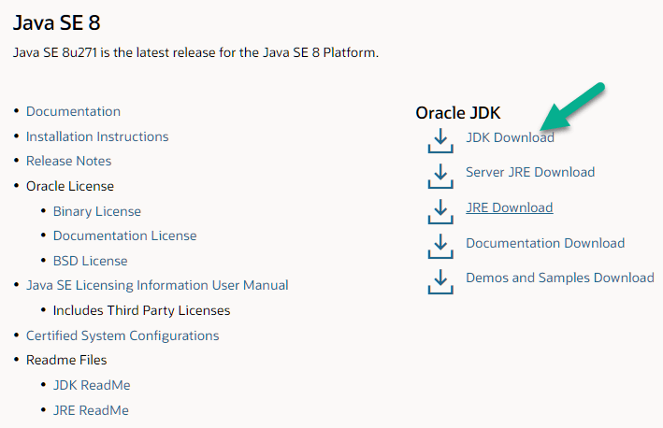

**Step 2)** Next,

1. Accept the License Agreement
2. Download the Java 8 JDK for your version 32 bit or JDK 8 download for windows 10 64 bit as per your system’s configruation.

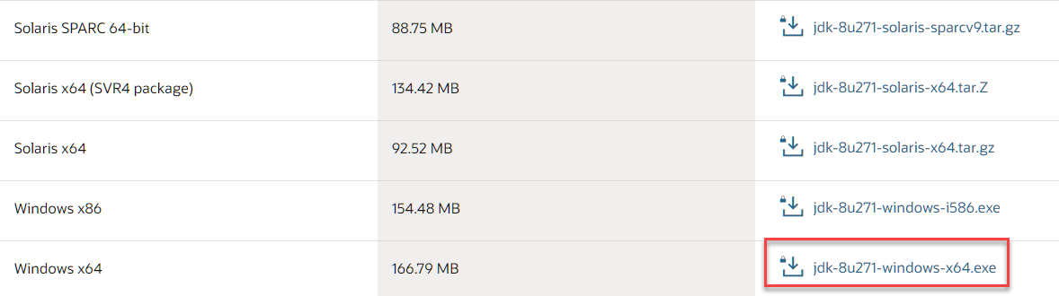

**Step 3)** Your instructions guide users through the process of accepting the Oracle Technology Network License Agreement for Oracle Java SE and signing up for an Oracle account if they don't have one.

This is a common procedure for downloading Java from the official Oracle website. If you have any specific questions or if there's anything else you'd like to include in the instructions, feel free to let me know!

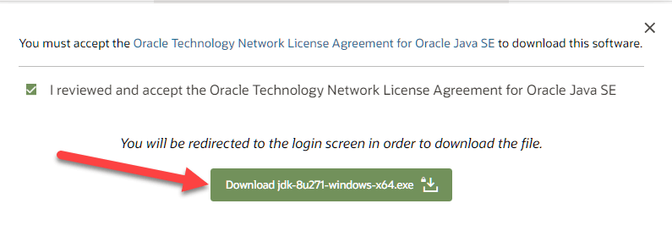

**Step 4)** After completing the download of Java JDK 8, run the executable file (exe) to initiate the JDK installation. Proceed by clicking the "Next" button in the installation wizard.

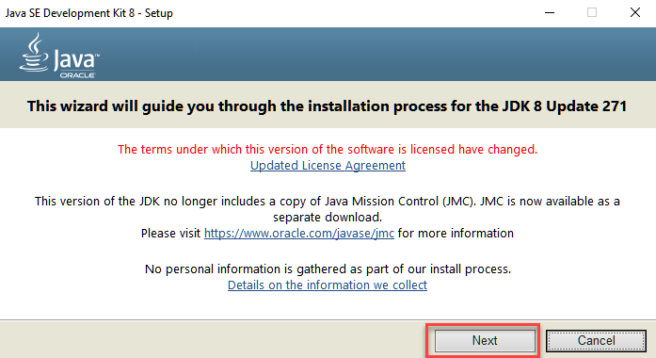

**Step 5)** Choose the desired PATH for Java installation on your Windows system, and then click the "Next" button to proceed with the installation.

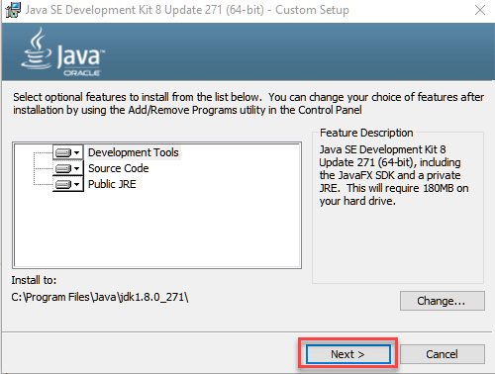

**Step 6)** After the successful installation of Java on your Windows system, click the "Close" button to complete the installation process.

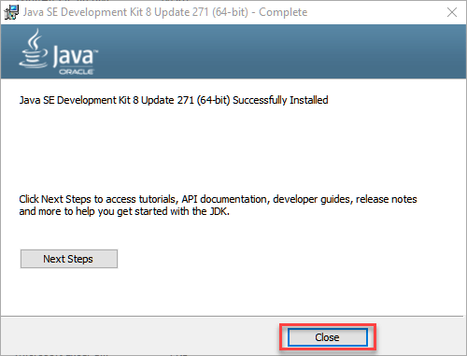

Setting the PATH and CLASSPATH environment variables in Java is crucial for ensuring that your system can locate and execute Java executables and libraries. Here are the steps to set these variables:

**Setting the PATH Variable:**

1. **Open System Properties:** - Right-click on the "This PC" or "Computer" icon on your desktop or in File Explorer. - Select "Properties."

2. **Access Advanced System Settings:** - Click on "Advanced system settings" on the left-hand side.

3. **Open Environment Variables:** - In the System Properties window, click on the "Environment Variables..." button.

4. **Edit or Add PATH Variable:** - In the Environment Variables window, under the "System variables" section, find and select the "Path" variable. - Click "Edit" if it exists, or "New" to create a new one.

- Add the path to the `bin` directory of your Java installation. For example, if your Java JDK is installed in "C:\Program Files\Java\jdk-13.0.1\bin," add this path.

5. **Verify the Configuration:** - Open a new command prompt and type `java -version` to verify that the PATH variable is set correctly.

**Setting the CLASSPATH Variable:**

1. **Go to Environment Variables:** - Follow steps 1 to 3 from the "Setting the PATH Variable" section.

2. **Edit or Add CLASSPATH Variable:** - In the Environment Variables window, under the "User variables" or "System variables" section, click "New" to add a new variable.

- Set the Variable Name as `CLASSPATH` and the Variable Value as the p ath to the directory Java libraries are located.

3. **Verify the Configuration:** - Open a new command prompt and type `echo %CLASSPATH%` to verify that the CLASSPATH variable is set correctly.

By properly configuring the PATH and CLASSPATH variables, you ensure that the Java executables and libraries are accessible system-wide.

**Step 1)** Right Click on the My PC and Select the properties

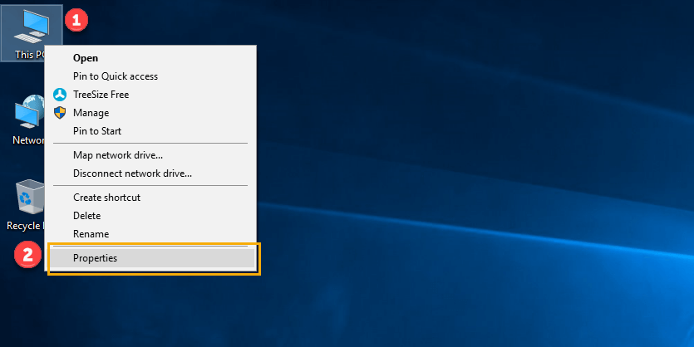

**Step 2)** Click on the advanced system settings

**Step 3)** Click on the Environment Variables

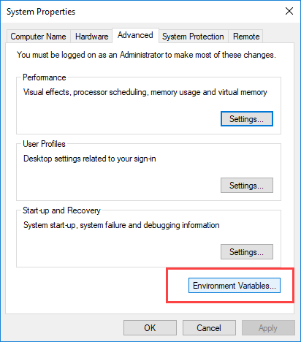

**Step 4)** Click on a new Button of the User variables

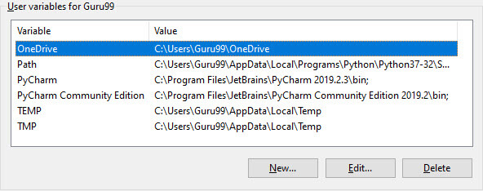

**Step 5)** Type PATH in the Variable name Text Box.

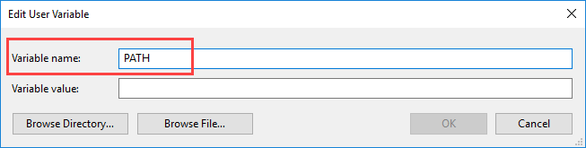

**Step 6)** Copy the path of bin folder which is installed in the JDK folder.

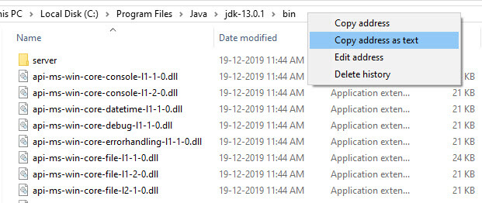

**Step 7)** Paste Path of the bin folder in the Variable value and click on the OK Button.

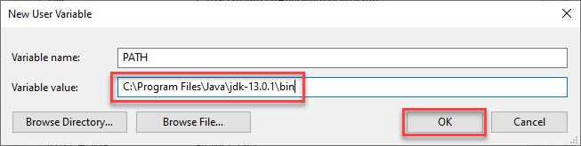

**Note:** If you already have a PATH variable created in your PC, then edit the PATH variable to

PATH = <JDK installation directory>\bin; %PATH%;

Here, %PATH% appends the existing path variable to our new value

**Step 8)**You can follow the same process to set CLASSPATH.

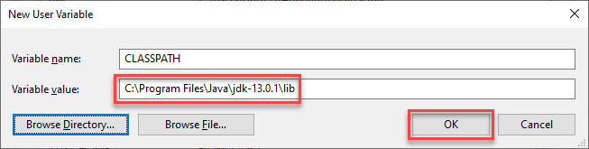

**Note:** If your java installation does not work after installation,then change classpath to

CLASSPATH = <JDK installation directory>\lib\tools.jar;

**Step 9)** Click on OK button

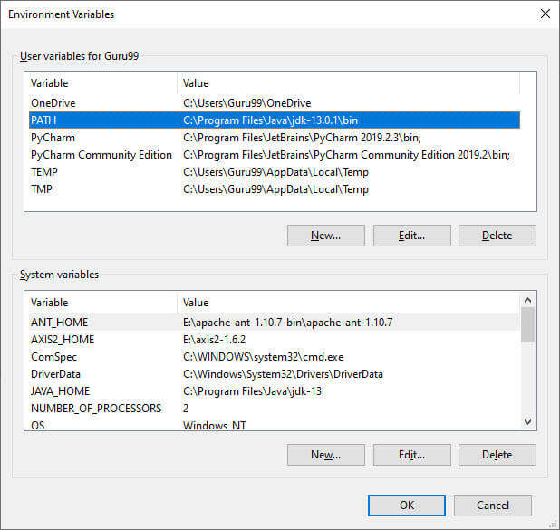

**Step 10)** Go to command prompt and type java commands. If you see a screen like below, Java is installed.

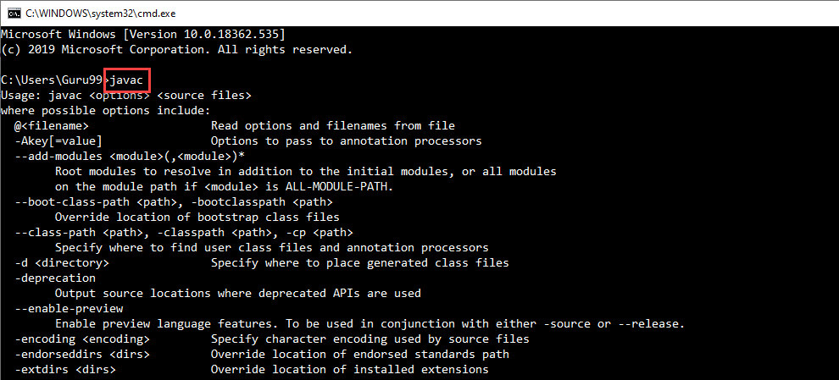

1. **Android Studio IDE and SDK Installation**

Indeed, installing Android Studio IDE and SDK can be a crucial step, and the time it takes may vary based on several factors. Your mention of needing a decent PC with sufficient RAM and disk space, as well as the note about the Android emulator's resource requirements, provides users with a realistic expectation of the installation process. If you have more details or specific instructions related to the installation, feel free to share them!

##### **Step 0: Pre-Installation Check List**

**1. **Install Java Development Kit (JDK):\*\***

- Before proceeding with Android SDK installation, make sure to install the Java Development Kit (JDK) by following the instructions in the "How to install JDK" guide. Confirm that your JDK version is 1.8 or above using the command "javac -version" in your terminal.

**2. **Uninstall Older Versions:\*\***

- Remove any existing older versions of "Android Studio" and "Android SDK" from your system before initiating the installation.

**3. **Be Patient During Installation:\*\***

- Keep in mind that both the installation and various operations may take a substantial amount of time. Avoid staring at your screen or the ceiling during this process. Instead, explore the resources available on "Android Developers" at [https://developer.android.com](https://developer.android.com). Developers can find valuable information in the "Developer Guides" section.

**4. **Install Two Significant Packages:\*\***

- The installation involves two major packages:

**1. **Android Studio (IDE) (approximately 1 GB):\*\***

- This is an Integrated Development Environment (IDE) based on IntelliJ, a popular Java IDE. It provides a comprehensive set of tools for Android application development.

**2. **Android SDK (Software Development Kit) (approximately 5 GB):\*\***

- This kit is essential for developing and testing Android apps. It includes various tools and libraries necessary for Android development.

##### **Step 1: Install "Android Studio IDE"**

Reference: "Install Android Studio" @ <https://developer.android.com/studio/install>.

##### (For Windows)

1. Check that environment variable JAVA_HOME is set to the JDK installation directory via command "set JAVA_HOME". Otherwise, Follow the steps [HERE](https://www3.ntu.edu.sg/home/ehchua/programming/howto/JDK_HowTo.html#Set-JAVA_HOME).
2. Check the system requirements for Android Studio/SDK @ <https://developer.android.com/studio#Requirements> e.g., For Windows 10, recommended 8GB of RAM, 4GB of disk space, and 1280x800 minimum screen resolution.
3. Go to "Android Studio" @ <https://developer.android.com/studio> ⇒ Click "Download Android Studio 3.6.x for Windows 64-bit (749MB)", e.g., "android-studio-ide-192.xxxxxxx-windows.exe".
4. Run the downloaded installer ⇒ You may watch a short video @ <https://developer.android.com/studio/install>.

##### **Step 2: Install Android SDK**

**STEPS FOR EXECUTING THE PROJECTS**

**Step 1:**

Open the Android Studio

**Step2:**

Choose a virtual device or Physical device from the menubar

**Step3:**

Click on the project and Run it.

**Step4:**View the application performance on virtual or Physical device.

**IMPLEMENTATION**

**Modules and Functionalities:**

**1. Admin:**

**- Login:**

**- Authenticate access to the admin panel with email and password.**

**- Hospital Management:**

**- Add Hospitals:**

**-** Enter details of new hospitals, including name, location, and contact information.

**- View Hospitals:**

**-** Access a list of all registered hospitals with their respective details.

**- View User Feedbacks:**

**-** Monitor and review user feedback about hospitals.

**- Add Healthcare Insurance:**

**-** Input and manage information related to healthcare insurance plans.

**2. User:**

**- Registration:**

**-** Register by providing necessary details.

**- Login:**

**-** Log in using email and password.

**- Hospital Search:**

**-** Search for hospitals based on location, services, or other criteria.

**- Doctor Selection:**

**-** Choose a doctor from the available list.

**- Appointment Booking:**

**-** Fix an appointment with the selected doctor.

**- View Appointment Status:**

**-** Check the status of booked appointments.

**- View Healthcare Insurance:**

**-** Access information about healthcare insurance plans within the application.

**3. Hospital:**

**- Login:**

**-** Authenticate access with hospital-specific credentials.

**- Doctor Management:**

**- Add Doctors:**

**-** Include information about new doctors, such as name, specialization, and availability.

**- View Appointments:**

**-** Access a list of scheduled appointments.

**- View User Feedback:**

**-** Review feedback provided by users.

**4. Doctor:**

**- Login:**

**-** Authenticate access with doctor-specific credentials.

**- View Appointments:**

**-** Check the list of appointments scheduled with the doctor.

**- Appointment Management:**

**- Accept/Reject Appointments:**

- Confirm or decline appointment requests.

**- Update Status:**

**-** Modify availability status or update other relevant information.

These modules and functionalities ensure a comprehensive and user-friendly healthcare management system, facilitating interactions among admins, users, hospitals, and doctors.

**Architecture:**

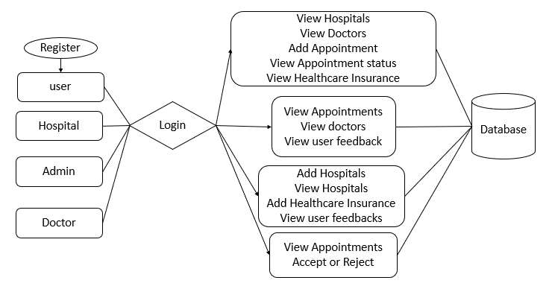

**SYSTEM DESIGN**

**UML DIAGRAMS**

UML, which stands for Unified Modeling Language, is a standardized and widely accepted modeling language in the realm of object-oriented software engineering. Managed by the Object Management Group, UML aims to serve as a common language for creating models of object-oriented computer software. The UML standard consists of two major components: a Meta-model and a notation. There is potential for the addition of a method or process to be associated with UML in the future.

UML is designed to be a comprehensive language for specifying, visualizing, constructing, and documenting the artifacts of software systems. It is not limited to software alone but is also applicable to business modeling and other non-software systems. Serving as a collection of best engineering practices, UML has proven successful in modeling large and complex systems.

UML plays a crucial role in the development of object-oriented software and the overall software development process. It predominantly employs graphical notations to express the design of software projects, making it an essential tool for software engineers and developers.

**GOALS:**

The design of the Unified Modeling Language (UML) is guided by several primary goals, aiming to enhance its effectiveness and versatility in the field of object-oriented software engineering:

**1.** **Ready-to-Use Visual Modeling Language:**

- Provide users with a readily applicable and expressive visual modeling language to enable the development and meaningful exchange of models.

**2.Extendibility and Specialization Mechanisms:**

- Offer mechanisms for extendibility and specialization, allowing users to build upon and customize the core concepts of UML as needed for specific applications.

**3. Independence of Programming Languages and Development Processes:**

- Remain independent of particular programming languages and development processes, ensuring broad applicability across diverse technological landscapes.

**4. Formal Basis for Understanding:**

- Provide a formal basis for understanding the modeling language, establishing a solid foundation for its usage and interpretation.

**5. Support Higher Level Development Concepts:**

- Support higher-level development concepts, including collaborations, frameworks, patterns, and components, to cater to the evolving needs of software engineering.

**USE CASE DIAGRAM:**

A use case diagram in the Unified Modeling Language (UML) is a behavioral diagram that focuses on capturing the functional requirements of a system from the user's perspective. Here are key points about use case diagrams:

1. **Actors**:

- Actors represent external entities (users or systems) that interact with the system. Actors can be individuals, groups, or other systems that have specific roles in the system.

2. **Use Cases:**

- Use cases represent distinct functionalities or features of the system that deliver value to the actors. Each use case describes a specific way the system interacts with an actor to fulfill a goal.

**3. System Boundary:**

- The system boundary defines the scope of the system being modeled. It encapsulates all the use cases and actors within the system.

**4. Association:**

- Lines (associations) connect actors to use cases, indicating which actors are involved in the execution of specific use cases.

**5. Include Relationship:**

- The "include" relationship indicates that one use case includes the functionality of another use case. It represents a relationship where a base use case includes the behavior of an included use case.

**6. Extend Relationship:**

- The "extend" relationship indicates that one use case can extend the behavior of another use case under certain conditions. It represents optional or conditional behavior.

**7. Generalization:**

- Generalization (inheritance) relationships can exist between use cases, where a more specialized use case inherits from a more general use case.

8. **System Boundary**:

- The system boundary defines the limits of the system under consideration.

**9. Multiplicity:**

- Multiplicity notations on associations indicate how many instances of one element are related to another.

**10. Use Case Descriptions:**

- Each use case may have a corresponding detailed description that provides more information about its behavior, preconditions, and postconditions.

11. **Diagram Organization**:

- Use case diagrams are typically organized with actors on the periphery and use cases in the center. The lines connecting actors to use cases represent interactions.

Use case diagrams are beneficial for stakeholders to understand the high-level functionalities of a system, the roles of different users or external systems, and the relationships between various use cases. They serve as an effective communication tool during the requirements analysis phase of software development.

**CLASS DIAGRAM:**

A class diagram in the Unified Modeling Language (UML) is a static structure diagram that provides a comprehensive visualization of the structure of a system. Here are key points about class diagrams:

**1. Representation of Classes:**

- Class diagrams represent classes in a system. A class is a blueprint for creating objects, encapsulating attributes (data) and methods (functions).

**2. Attributes and Operations:**

- Each class in the diagram includes attributes (properties or data members) and operations (methods or functions). These elements define the structure and behavior of the class.

**3. Relationships Between Classes:**

- Class diagrams illustrate relationships between classes. Common relationships include associations, dependencies, generalizations (inheritance), and aggregations.

**4. Associations:**

- Associations show how classes are connected to each other. They indicate the relationships and connections between instances of different classes.

5. **Multiplicity**:

- Multiplicity notations (such as "1", "0..1", "*", etc.) indicate the number of instances of one class related to another. They define how many objects participate in a particular relationship.

**6. Inheritance (Generalization):**

- Inheritance relationships represent the "is-a" relationship between classes. A subclass inherits attributes and operations from a superclass.

**7. Aggregation and Composition:**

- Aggregation and composition relationships express part-whole associations between classes. They define how classes are composed of other classes.

**8. Visibility and Access Control:**

- Class diagrams may specify the visibility of attributes and operations (e.g., public, private, protected) to indicate access control.

**9. Package and Namespace:**

- Class diagrams may include packages or namespaces to organize classes into higher-level structures.

**10. Static Elements:**- Class diagrams can include static elements, such as class methods or attributes, denoted by an underline.

**11. Role Names:**

- Role names may be used to clarify the purpose or role of a class in a specific relationship.

Class diagrams are essential for understanding the static structure of a system and are widely used in software engineering for design, documentation, and communication among stakeholders. They provide a foundational view of the system's architecture, aiding developers and architects in the design and implementation phases of software development.

**SEQUENCE DIAGRAM:**

In Unified Modeling Language (UML), a sequence diagram is a type of interaction diagram that visualizes the interactions and the order in which processes or components operate with one another. Here are some key points about sequence diagrams:

**1. Interaction Visualization:**

- Sequence diagrams depict the interactions and flow of messages or actions between different elements, such as objects or components, in a system.

**2. Message Flow:**

- They illustrate the chronological order of messages exchanged between objects during the execution of a particular scenario or use case.

3. **Lifelines**:

- Lifelines represent the different elements or objects involved in the interaction. Each lifeline corresponds to an instance of a class, showing its existence over a specific period.

**4. Activation Bars:**

- Activation bars represent the duration of an object's involvement in an interaction. They show when an object is active and when it is inactive.

**5. Focus on Time and Order:**

- Sequence diagrams emphasize the temporal aspects of interactions, providing a time-ordered view of the events taking place during the execution of a system.

**6. Use Cases and Scenarios:**

- Sequence diagrams are particularly useful for modeling and understanding specific use cases or scenarios, showcasing how different components collaborate to achieve a goal.

**7. Communication Between Objects:**

- Arrows represent messages exchanged between objects, indicating the direction of communication and the type of message being sent.

r**COLLABORATION DIAGRAM:**

It seems like there might be a misunderstanding. In both sequence diagrams and collaboration diagrams (also known as communication diagrams) in UML, the ordering of method calls is indicated by numbering the messages to represent the sequence of interactions. Both diagrams aim to illustrate how objects collaborate to achieve a particular functionality.

**Here's a brief comparison:**

**1. **Sequence Diagram:\*\***

- Focuses on the time ordering of messages and interactions between objects over a timeline.

- Represents the chronological sequence of messages sent between objects.

- Emphasizes the temporal aspects of the interactions.

- Vertical lifelines represent objects, and messages flow vertically between them.

**2. Collaboration Diagram (Communication Diagram):**

- Focuses on the structural organization of objects and how they interact to achieve a goal.

- Represents the flow of messages and interactions between objects without a strict timeline.

- Emphasizes the relationships and connections between objects.

- Objects are represented by rectangles, and messages flow horizontally between them.

While sequence diagrams are more oriented toward showing the chronological order of interactions over time, collaboration diagrams focus on depicting how objects are connected structurally, with less emphasis on time.

Both diagrams can be used to model similar scenarios, and the choice between them often depends on the specific aspects that you want to emphasize in your visualization. It's worth noting that UML diagrams are complementary, and different diagrams serve different purposes in conveying information about a system.

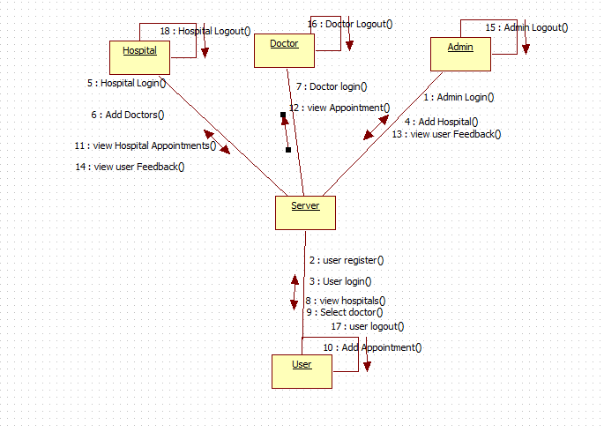

**ACTIVITY DIAGRAM:**

Activity diagrams in the Unified Modeling Language (UML) are a type of behavioral diagram that illustrates the flow of activities and actions within a system or a specific business process. These diagrams are particularly useful for modeling business processes, system workflows, and the dynamic aspects of a system.

**Key features and components of activity diagrams include:**

**1. Activity:** Represents a specific action or operation in the workflow. Activities are usually depicted as rounded rectangles.

**2. Action:**Represents a basic step or operation within an activity. Actions are shown as rectangles with rounded corners.

**3. Control Flow:** Represents the sequence in which activities and actions are performed. It is depicted using arrows connecting activities and actions.

**4. Decision Nodes:** Represent points in the workflow where a decision is made. The flow may follow different paths based on conditions. Decision nodes are usually diamond-shaped.

**5. Merge Nodes:** Represent the merging of multiple flows into a single flow after parallel or alternative paths. Merge nodes are often shown as diamond shapes with a plus sign inside.

**6. Fork Nodes:** Indicate the start of parallel paths in the workflow. Fork nodes are depicted as a line splitting into two or more branches.

7. **Join Nodes**:Indicate the merging of parallel paths back into a single flow. Join nodes are shown as a line coming together from two or more branches.

**8. Initial Node:** Represents the starting point of the activity diagram. It is often depicted as a filled-in circl**e.**

**9. Final Node:** Represents the end point of the activity diagram. It is usually shown as a circle with a dot inside.

Activity diagrams are versatile and can be used to model various types of workflows, including business processes, system processes, and use cases. They help stakeholders, including analysts and developers, to understand the flow of activities within a system and identify possible points of decision or concurrency.



**Component Diagram:**



**Deployment Diagram:**



**ER Diagram**:

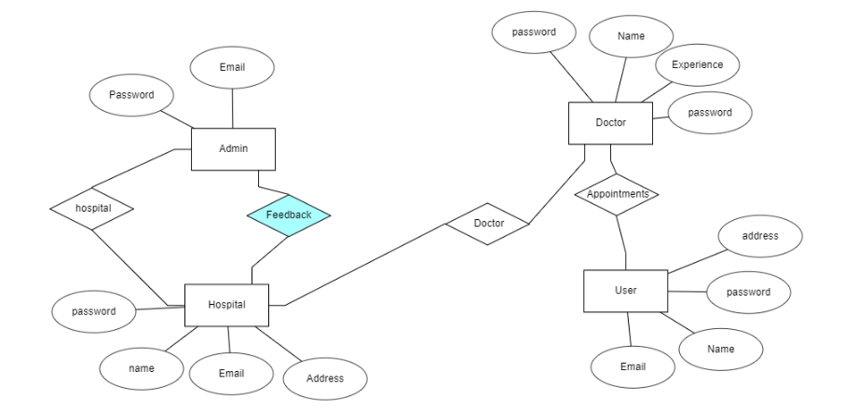

**DFD Diagram:**

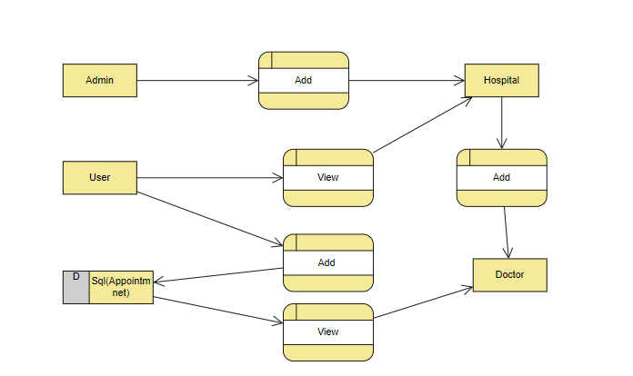

**Data Dictionary:**

A data dictionary serves as a repository of metadata, which is information about the database. This critical component contains essential details regarding the database, including its contents, access permissions, physical storage location, and more. The data dictionary plays a pivotal role in database management and administration. While regular users typically do not directly interact with the data dictionary, it is a key resource for database administrators.

Key points about a data dictionary:

**1. Metadata Repository:**

- It stores metadata, which includes information about the structure, organization, and characteristics of the database.

**2. Information Contents:**

- Contains details about the data elements, relationships between tables, data types, constraints, and security settings within the database.

**3. Access Control:**

- Specifies who is allowed to access the database and what level of permissions or restrictions apply to different users.

**4. Physical Storage Details:**

- Provides information about the physical storage locations of data within the database, facilitating efficient data retrieval and management.

**5. Administrative Handling:**

- Typically managed and maintained by database administrators who use the data dictionary to ensure the integrity, security, and efficient performance of the database.

The data dictionary serves as a centralized source of crucial information, aiding administrators in database design, maintenance, and optimization.

Indeed, a data dictionary typically includes comprehensive information about various aspects of the database structure and organization. Here are some common elements found in a data dictionary:

**1. Names of Database Tables and Schemas:**

- To retrieve a list of all tables present in a database along with their corresponding schemas, you can use SQL queries. The specific query may vary depending on the type of database you are using

**2. Details about Tables:**

- Information about each table, including ownership, security constraints, creation date, and other relevant details.

**3. Physical Information about Tables:**

- Specifies physical details such as storage locations, file structures, and storage methods for each table in the database.

**4. Table Constraints:**

- Enlists constraints applied to tables, including primary key attributes, foreign key relationships, unique constraints, and other integrity constraints.

**5. Database Views Information:**

- Includes details about database views, such as their names, definitions, and visibility.

Having this information in a data dictionary is crucial for database administrators, as it facilitates effective database management, maintenance, and optimization. It serves as a valuable reference for understanding the structure, relationships, and constraints within the database.

|  |  |  |  |  |
| --- | --- | --- | --- | --- |
| **Field Name** | **Data type** | **Variable size** | **Key** | **Data** |
| **id** | **Int** | **20** | **Primary key** | **1** |
| **Name** | **varchar** | **20** | **NULL** | **test** |
| **email** | **varchar** | **30** | **NULL** | **rest@gmail.com** |
| **password** | **varchar** | **30** | **NULL** | **Test123** |
| **mobile** | **number** | **10** | **NULL** | **9999999999** |

**SOFTWARE DEVELOPMENT LIFE CYCLE**

The Agile process model is indeed characterized by its emphasis on iterative development and adaptability. Here are some key principles and characteristics of the Agile methodology:

1. **Iterative and Incremental**: The development process is divided into small, manageable iterations. Each iteration results in a potentially shippable product increment, allowing for regular inspection and adaptation.

2. **Customer Collaboration:** Continuous customer involvement throughout the development process is crucial. Customers and stakeholders provide feedback at the end of each iteration, ensuring that the product aligns with their expectations.

3. **Adaptive Planning**: Agile projects embrace changes in requirements, even late in the development process. The focus is on responding to change rather than following a rigid plan. Agile plans are adjusted at the end of each iteration based on feedback and evolving priorities.

4. **Cross-Functional Teams**: Agile teams are composed of individuals with diverse skills, including developers, testers, designers, and other necessary roles. This fosters collaboration and allows the team to work cohesively to deliver valuable increments.

5. **Continuous Delivery**: The goal is to deliver a working product at the end of each iteration. This approach enables the customer to receive tangible results frequently, fostering transparency and maintaining a consistent pace of delivery.

6. **Emphasis on Individuals and Interactions**: Agile values the interactions and collaboration between team members and stakeholders. Face-to-face communication is often favored, and the focus is on building a motivated and empowered team.

7. **Working Software as the Primary Measure of Progress:** The success of an Agile project is primarily measured by the delivery of functional and valuable software. Features are prioritized based on their importance and customer value.

8. **Sustainable Development**: Agile promotes a sustainable pace of work to avoid burnout and ensure the long-term success of the team. This involves maintaining a consistent and manageable workload.

Agile frameworks such as Scrum, Kanban, and Extreme Programming (XP) provide specific practices and roles to implement these principles effectively. The Agile approach is widely used in software development and has also found application in various other industries.

Agile is not a single, rigid process but rather a group of development processes sharing basic characteristics with subtle differences. Some Agile SDLC models include Crystal, Feature-driven development, Scrum, Extreme programming (XP), Lean development, and Unified process. The Agile model decomposes requirements into small, incrementally developed parts, adopting an iterative development cycle that is small, manageable, and can be completed within a few weeks. The emphasis is on flexibility, adaptability, and delivering value in shorter cycles rather than making long-term plans

In the Agile model, the iterative and incremental nature of development is organized into fixed time frames known as iterations or sprints. Each iteration typically follows these steps:

1. **Requirement Gathering**: Identifying and gathering the customer's requirements. This includes understanding their needs and priorities for the upcoming iteration.

2. **Requirement Analysis**: Analyzing the requirements to create user stories or tasks. Breaking down the work into manageable units that can be completed within the iteration.

3. **Design Coding**: Designing and coding the features or functionalities outlined in the user stories. This is where the actual development work takes place.

4. **Unit Testing**: Performing testing at the unit level to ensure that individual components or units of code function as intended.

5. **Acceptance Testing**: Conducting tests to verify that the developed features meet the acceptance criteria defined for the iteration. This often involves collaboration with stakeholders and the customer representative.

The concept of a Time Box in Agile ensures that each iteration has a fixed duration, typically ranging from one to four weeks. This fixed timeframe helps in managing and controlling the development process. The development team has the flexibility to adjust the scope or features being delivered within the Time Box, but the end date remains constant. This allows for regular releases of usable and valuable software at the end of each iteration. The entire Agile development process is characterized by adaptability, continuous feedback, and a focus on delivering customer value.

The central principle of the Agile model revolves around delivering an increment to the customer after each Time Box. This iterative and time-bound approach allows for frequent and consistent delivery of valuable functionality, fostering adaptability and responsiveness to changing requirements throughout the software development process. The Time Box concept helps in managing expectations, ensuring regular customer engagement, and maintaining a rhythm of continuous delivery within predetermined timeframes.

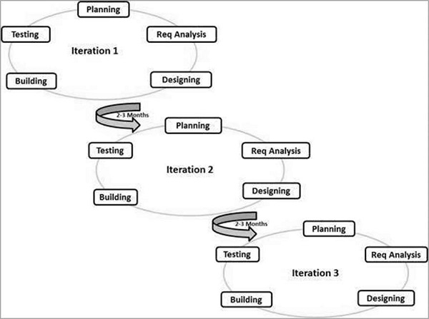

**Principles of Agile model:**

* Agile methodology indeed emphasizes customer collaboration and working software over extensive documentation. This iterative and flexible approach allows for continuous feedback and adaptation, ensuring that the end product aligns with the customer's evolving needs. Regular reviews and discussions with the customer representative contribute to a more collaborative development process. The focus on delivering a working product at the end of each iteration promotes a more responsive and customer-centric development cycle compared to traditional, more rigid methodologies.
* Frequent delivery of incremental versions of the software to the customer representative in intervals of few weeks.
* Requirement change requests from the customer are encouraged and efficiently incorporated.
* It emphasizes on having efficient team members and enhancing communications among them is given more importance. It is realized that enhanced communication among the development team members can be achieved through face-to-face communication rather than through the exchange of formal documents.
* It is recommended that the development team size should be kept small (5 to 9 people) to help the team members meaningfully engage in face-to-face communication and have collaborative work environment.
* Agile development process usually deploys Pair Programming. In Pair programming, two programmers work together at one work-station. One does code while the other reviews the code as it is typed in. The two programmers switch their roles every hour or so.

**Advantages:**

* Working through Pair programming produce well written compact programs which has fewer errors as compared to programmers working alone.
* It reduces total development time of the whole project. Customer representatives get the idea of updated software products after each iteration. So, it is easy for him to change any requirement if needed.

**Disadvantages:**

* Due to lack of formal documents, it creates confusion and important decisions taken during different phases can be misinterpreted at any time by different team members.
* Due to the absence of proper documentation, when the project completes and the developers are assigned to another project, maintenance of the developed project can become a problem.

**SOFTWARE ENVIRONMENT**

**Software Environment**

Android is a software stack for mobile devices that includes an operating system, middleware and key applications. Google Inc. purchased the initial developer of the software, Android Inc., in 2005.

Android's mobile operating system is based on the Linux kernel. Google and other members of the Open Handset Alliance collaborated on Android's development and release.

Your statement provides a good overview of the Android ecosystem, but there are a couple of points to clarify:

**1. Android Open-Source Project (AOSP):**

- The Android Open-Source Project is indeed responsible for the maintenance and development of the Android operating system. It provides the source code for Android, allowing manufacturers to customize and create their own versions of the OS for their devices.

**2. Android as the World's Best-Selling Smartphone Platform:**

- As of my last knowledge update in January 2022, Android has consistently been one of the most widely used smartphone platforms globally. It's known for its open-source nature, customization options, and widespread adoption by various device manufacturers.

**3. Android SDK and Java Programming Language:**

- The Android Software Development Kit (SDK) is a set of tools and APIs provided by Google to facilitate the development of Android applications. While Java has been a traditional language for Android development, it's worth noting that Kotlin is also supported and encouraged by Google.

**4. Large Community of Developers:**

- Android has a vast and active community of developers who contribute to the platform's growth. This community is involved in creating a wide range of applications that enhance the functionality of Android devices.

**5. Over 250,000 Apps Available:**

- The number of available apps on the Google Play Store has likely grown since my last update in January 2022. As of then, there were over 3 million apps on the Google Play Store.

Overall, your statement captures the essence of Android as an open-source platform with a robust development community and a diverse range of applications available for users.

* Features: -
* Your list outlines key components and features of the Android platform. Let's break down each point:
* **1. Application Framework Enabling Reuse and Replacement of Components:**
* - Android provides a flexible application framework that allows developers to build and replace components easily. This promotes code reuse and modularity.
* **2. Dalvik Virtual Machine Optimized for Mobile Devices:**
* - Dalvik is the former virtual machine for Android applications. It's designed for mobile devices and optimized for resource efficiency.
* **3. Integrated Browser Based on the Open-Source WebKit Engine:**
* - Android includes a built-in web browser that uses the open-source WebKit engine. This provides a browsing experience optimized for mobile devices.
* **4. Optimized Graphics Powered by a Custom 2D Graphics Library; 3D Graphics Based on OpenGL ES 1.0 Specification (Hardware Acceleration Optional):**
* - Android features a custom 2D graphics library for optimized 2D rendering. Additionally, 3D graphics are supported through the OpenGL ES 1.0 specification, with optional hardware acceleration for improved performance.
* **5. SQLite for Structured Data Storage:**
* - SQLite is the embedded database engine used in Android for structured data storage. It's a lightweight and efficient relational database management system.
* **6. Media Support for Common Audio, Video, and Still Image Formats (MPEG4, H.264, MP3, AAC, AMR, JPG, PNG, GIF):**
* - Android supports a variety of media formats, ensuring compatibility with common audio, video, and image file types.
* **7. GSM Telephony (Hardware Dependent):**
* - Android includes support for GSM telephony, allowing devices to connect to mobile networks. The availability of GSM features depends on the hardware.
* **8. Bluetooth, EDGE, 3G, and Wi-Fi (Hardware Dependent):**
* - Android supports various connectivity options, including Bluetooth, EDGE, 3G, and Wi-Fi. The availability of these features depends on the device's hardware.
* **9. Camera, GPS, Compass, and Accelerometer (Hardware Dependent):**
* - Android devices can leverage hardware components such as cameras, GPS receivers, compasses, and accelerometers for enhanced functionality.
* **10. Rich Development Environment Including a Device Emulator, Tools for Debugging, Memory and Performance Profiling, and a Plugin for the Eclipse IDE:**
* - Android provides a robust development environment with tools for debugging, memory and performance profiling. The Android Emulator allows developers to test their applications on virtual devices. There's also a plugin for the Eclipse IDE (though Android Studio has become the primary IDE for Android development)..

## Android Architecture

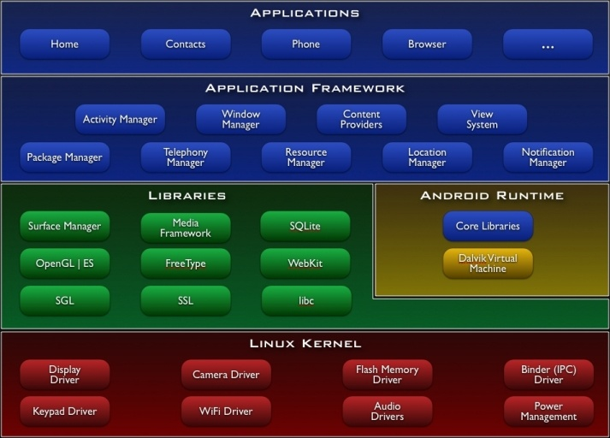

## Libraries

Your breakdown provides a concise overview of some core C/C++ libraries in the Android system. Let's explore each library:

**1. System C Library:**

- The System C library is a BSD-derived implementation of the standard C system library (libc). It's specifically tuned for embedded Linux-based devices. This library is fundamental to the functioning of the Android system, providing essential system-level functionality.

**2. Media Libraries:**

- Based on Packet Video's Open CORE, the media libraries in Android support playback and recording of various audio and video formats, as well as static image files. This includes popular formats such as MPEG4, H.264, MP3, AAC, AMR, JPG, and PNG. These libraries enable multimedia capabilities in Android applications.

3. **Surface Manager**:

- The Surface Manager plays a crucial role in managing access to the display subsystem. It seamlessly composites 2D and 3D graphic layers from multiple applications. This ensures efficient rendering and display of graphical content on Android devices.

4. **LibWebCore**:

- LibWebCore serves as a modern web browser engine, powering both the Android browser and an embeddable web view. It is responsible for rendering web content, providing the underlying technology for web-related functionalities in Android applications.

**5. SGL - The Underlying 2D Graphics Engine:**

- SGL, the underlying 2D graphics engine, contributes to the rendering of 2D graphics in the Android system. It plays a crucial role in handling graphical elements and ensuring smooth graphics performance.

These libraries collectively form the backbone of the Android operating system, supporting a range of functionalities from system-level operations to multimedia processing and web browsing. They are integral to the development and execution of Android applications.

## Android Runtime

Your description provides a clear overview of the core aspects of the Android runtime environment, particularly the Dalvik virtual machine. Let's break down the key points:

**1. Core Libraries in Android:**

- Android includes a set of core libraries that offer functionality similar to the core libraries of the Java programming language. These libraries form the foundation for Android applications, providing essential features for developers.

**2. Dalvik Virtual Machine:**

- Every Android application operates within its own process, each with its instance of the Dalvik virtual machine (VM). The Dalvik VM is designed to efficiently run multiple VM instances on a device. It executes files in the Dalvik Executable (.dex) format, optimized for a minimal memory footprint.

**3. Dalvik Executable (.dex) Format:**

- Android applications are compiled into the Dalvik Executable format (.dex) by the included "dx" tool. This format is tailored for efficient execution on resource-constrained mobile devices, contributing to optimized memory usage.

**4. Register-Based VM:**

- The Dalvik VM is register-based, as opposed to a stack-based virtual machine. This design choice enhances performance and responsiveness, making it well-suited for mobile environments.

**5. Linux Kernel Dependency:**

- The Dalvik VM relies on the Linux kernel for essential underlying functionalities such as threading and low-level memory management. This dependency ensures a robust foundation for the execution of Android applications.

Overall, the combination of the Dalvik VM, the .dex format, and the reliance on the Linux kernel contributes to the efficient and resource-conscious operation of Android applications on a diverse range of devices. These elements are essential components of the Android runtime environment.

## Linux Kernel

Your detailed explanation provides a comprehensive overview of various aspects related to the Android operating system. Let's summarize the key points:

**1. Linux Kernel Integration:**

- Android relies on Linux version 2.6 for core system services, including security, memory management, process management, network stack, and the driver model. The Linux kernel acts as an abstraction layer between the hardware and the rest of the software stack.

**2. Open-Source Nature of Linux Kernel:**

- The Linux kernel is open-source and released under the GNU General Public License version 2 (GPLv2). It was initially created by Linus Torvalds in 1991 and has since received contributions from thousands of developers worldwide.

**3. Virtual Machine Support:**

- The Linux kernel has extensive support for and runs on many virtual machine architectures, both as the host and guest operating system. Virtual machines often emulate Intel x86 processors, with occasional emulation of PowerPC or ARM processors.

**4. Google's Adoption of Linux for Android:**

- Google adopted the Linux kernel to power the Android mobile device platform. This decision aimed to provide a flexible and upgradable system. Google collaborated with hardware and software partners to bring Android to a variety of devices.

**5. Hardware Running Android:**

- Android primarily supports the ARM architecture. It is used as the operating system for cellphones, netbooks, tablets, TVs, and other devices. The first commercially available phone

running Android was the HTC Dream, released in 2008.

**6. Early Challenges in Android Development:**

- Early feedback on developing applications for Android highlighted challenges, including bugs, lack of documentation, and inadequate QA infrastructure. Despite these issues, Android-targeted applications began to appear shortly after the platform's announcement.

**7. Android Software Development Kit (SDK):**

- The Android SDK includes a set of development tools such as a debugger, libraries, a handset emulator (based on QEMU), documentation, sample code, and tutorials. The officially supported IDE is Eclipse, using the Android Development Tools (ADT) Plugin.

**8. APK Format for Android Applications:**

- Android applications are packaged in .apk format and stored in the /data/app folder on the Android OS. The APK package contains .dex files (Dalvik executables), resource files, and other components.

This summary captures the key elements of your provided information regarding the Android operating system and its development environment.

### Android Operation System

### Your description provides a concise overview of key aspects of the Android operating system and its development environment. Let's highlight the main points:

### 1. **Operating System Foundation:**

### - Android is an operating system based on Linux and incorporates a Java programming interface. It is developed and led by the Open Handset Alliance, with Google as a prominent member.

### 2. **Dalvik Virtual Machine (DVM):**

### - Android uses the Dalvik Virtual Machine (DVM), a special virtual machine designed for the Android platform. Unlike standard Java bytecode, Android applications use bytecode specific to Dalvik.

### 3. **Bytecode Conversion and Packaging:**

### - Android provides the "dx" tool to convert Java Class files into Dalvik Executable (.dex) files. The packaging of Android applications into .apk (Android Package) files is done using the "aapt" tool. Google's Android Development Tools (ADT) for Eclipse automates these processes during deployment.

### 4. **Graphics Support:**

### - Android supports both 2-D and 3-D graphics using the OpenGL libraries. This enables developers to create visually appealing and dynamic user interfaces.

### 5. **Data Storage:**

### - Android applications can store data in a SQLite database, providing a reliable and efficient mechanism for structured data storage.

### 6. **Isolation and Security:**

### - Each Android application runs in its own process and operates under its unique user ID, automatically generated by the Android system during deployment. This isolation ensures that misbehaving applications do not easily affect others, contributing to the overall security of the system.

### This summary captures the key features and characteristics that distinguish Android in terms of its technical foundation, development tools, graphics capabilities, data storage options, and security mechanisms.

### Important Android components

### Your detailed explanation covers various fundamental aspects of Android application development, including the components and concepts involved. Let's break down the key points:

### 1. **Activity:**

### - Represents the presentation layer of an Android application, such as a user interface screen. Multiple activities can be present, and the application can switch between them during runtime.

### 2. **Views:**

### - The user interface of activities is built using widget classes that inherit from "android.view.View." Layouts of views are managed by "android.view.ViewGroups."

### 3. **Services:**

### - Perform background tasks without providing a user interface. They can notify users via the Android notification framework.

### 4. **Content Provider:**

### - Provides data to applications, allowing them to share data with other applications. Android includes a SQLite database that can serve as a data provider.

### 5. **Intents:**

### - Asynchronous messages allowing applications to request functionality from other services or activities. Intents can be explicit (directly calling a service or activity) or implicit (asking the Android system for registered services and applications for an intent).

### 6. **Broadcast Receiver:**

### - Receives system messages and implicit intents, allowing applications to react to changed conditions in the system.

### 7. **Java Virtual Machine (JVM):**

### - Enables the execution of Java bytecode, providing a platform-independent environment. JVM can execute bytecode compiled from languages other than Java.

### 8. **Write Once, Run Anywhere (WORA):**

### - The concept behind Java, achieved using the JVM. JVM allows Java programs to be written once and run on any platform that supports a compatible JVM.

### 9. **Java Runtime Environment (JRE):**

### - Includes a JVM along with a set of standard class libraries that implement the Java API. Forms the execution environment for Java programs.

### 10. **Java Archive (.jar):**

### - Multiple class files may be packaged together in a .jar file for easier distribution of large programs.

### 11. **Java Application Launcher:**

### - The `java` launcher provides a standard way of executing Java code.

### 12. **Just-In-Time Compiler (JIT):**

### - Most JVMs today use JIT compiling for greater speed, interpreting the JVM instruction set or using a JIT compiler like Oracle's Hotspot.

### 13. **Stack-Based Architecture:**

### - The JVM has a stack-based architecture similar to a microcontroller/microprocessor. It also supports low-level features for Java-like classes and methods.

### Your explanation provides a comprehensive overview of the Android development environment, Java Virtual Machine, and related concepts..

**Download the Android SDK**

The steps provided offer a clear and concise overview of how to set up the Android SDK. Let's elaborate on each step:

**1. **Prepare Your Development Computer:\*\***

- Ensure that your development computer meets the system requirements for the Android SDK. This may include specific operating system versions, memory, and other hardware/software specifications.

**2. **Install the SDK Starter Package:\*\***

- Download and install the SDK starter package from the provided table. If you are using Windows, you can use the installer for assistance with the initial setup.

**3. **Install the ADT Plugin for Eclipse:\*\***

- If you plan to develop in Eclipse, install the Android Development Tools (ADT) Plugin. This plugin integrates with the Eclipse IDE to facilitate Android application development.

**4. **Add Android Platforms and Components:\*\***

- Use the Android SDK and AVD Manager to add Android platforms and other necessary components to your SDK. This ensures that you have the required tools for developing Android applications.

**5. **Explore the Contents of the Android SDK (Optional):\*\***

- Optionally, explore the contents of the Android SDK to familiarize yourself with its structure and components. This step can provide insights into the tools and resources available for Android development.

**6. **Get Started:\*\***

- Download the appropriate package from the provided table and follow the guide to Installing the SDK. This guide will likely include detailed instructions on the installation process, ensuring a smooth setup.

By following these steps, developers can establish a robust development environment for Android applications. The integration with Eclipse and the addition of necessary components ensure that the SDK is equipped with the tools needed for effective Android development.

# Installing the SDK

The provided instructions offer a detailed guide on preparing your development computer for Android SDK. Let's break down the key steps:

**1. Confirm System Requirements:**

- Before starting with the Android SDK, ensure that your development computer meets the system requirements. This may involve installing the Java Development Kit (JDK) if not already installed.

**2. Install Eclipse (If Required):**

- If you plan to develop in Eclipse with the Android Development Tools (ADT) Plugin, make sure you have a suitable version of Eclipse installed. The recommended version is "Eclipse Classic." You can download Eclipse from the provided location.

**3. Install Android Development Tools (ADT) Plugin:**

- Utilize the Eclipse update manager to install all available plugins for the Android Development Tools (ADT). The provided URL, https://dl-ssl.google.com/android/eclipse/, is specified for obtaining these plugins.

By following these steps, you'll ensure that your development environment is properly set up with the required tools and plugins for Android development in Eclipse. This includes confirming system requirements, installing Eclipse, and integrating the ADT Plugin for a streamlined development experience.

### Configuration

In Eclipse open the Preferences dialog via Windows -> Preferences. Select Android and maintain the installation path of the Android SDK.

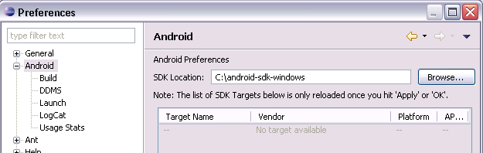

Select Window -> Android SDK and AVD Manager from the menu.

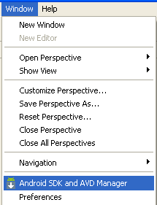

Select available packages and select the latest version of the SDK.

Step 2. The process outlined in these instructions is about obtaining the Android SDK starter package. Let's break down the key steps:

**1. Download the SDK Starter Package:**

- The SDK starter package provides the core SDK Tools and is not a complete development environment. It serves as the foundation, and additional SDK components can be downloaded using these tools.

- Ensure you have the latest version of the SDK starter package by getting it from the SDK download page.

**2. Unpack the SDK Files (For .zip or .tgz Packages):**

- If you downloaded a .zip or .tgz package, unpack it to a designated location on your machine. The default directory name is typically "android-sdk-<machine-platform>."

**3. Run the Windows Installer (For .exe File):** - If you downloaded the Windows installer (.exe file), execute it. The installer checks for the Java SE Development Kit (JDK) and installs it if necessary. It then installs the SDK Tools into a default location, which can be modified if needed.

**4. Note the SDK Directory:**

- Make a note of the name and location of the SDK directory on your system. You will need this information later when setting up the ADT plugin and when using the SDK tools via the command line.

By following these steps, you'll acquire the SDK starter package and ensure that the core SDK Tools are properly set up on your machine. This serves as the initial setup for Android development, and additional components can be downloaded as needed.

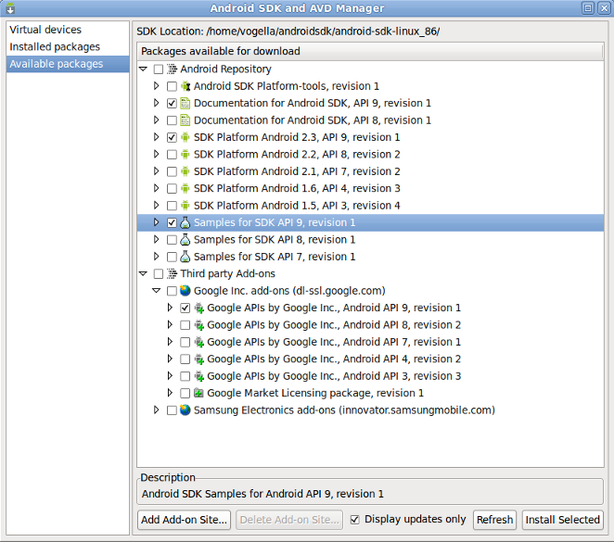

## Step 3. Installing the ADT Plugin for Eclipse

This section provides information about the Android Development Tools (ADT) plugin for the Eclipse IDE. Let's break down the key points:

**1. ADT Plugin for Eclipse:**

- Android offers a custom plugin for the Eclipse IDE called Android Development Tools (ADT).

- The ADT plugin is designed to enhance Eclipse's capabilities, providing an integrated environment for building Android applications.

**2. Key Features of ADT:**

- Quickly set up new Android projects.

- Create application user interfaces (UI) efficiently.

- Debug applications using the Android SDK tools.

- Export signed or unsigned APKs for distribution.

**3. Recommendation for Development:**

- Developing in Eclipse with ADT is highly recommended, considered the fastest way to start Android development.

**4. Installation of ADT:**

- If you choose to use ADT for Android development, the guide suggests installing it now.

- Refer to the "Installing the ADT Plugin" guide for step-by-step installation instructions.

**5. Alternative IDEs:**

- If you prefer to work in a different Integrated Development Environment (IDE), it's mentioned that you don't need to install Eclipse or ADT.

- Directly using the SDK tools is an option for building and debugging your application in alternative IDEs.

**6. Introduction to Android Application Development:**

- For those working in other IDEs, the "Introduction to Android Application Development" is referenced as a guide outlining major steps in the development process.

By providing these options, Android accommodates developers who prefer different IDEs while highlighting the benefits of using Eclipse with ADT for a streamlined Android development experience.





## Step 4. Adding Platforms and Other Component

The final step in setting up the Android SDK involves using the Android SDK and AVD Manager to download essential SDK components. Let's break down the key points:

**1. Android SDK and AVD Manager:**

- The Android SDK and AVD Manager is a tool included in the SDK starter package.

- Its purpose is to download essential SDK components into your development environment.

**2. Modular Structure of SDK:**

- The SDK follows a modular structure, separating major parts into installable components.

- These components include Android platform versions, add-ons, tools, samples, and documentation.

**3. Contents of SDK Starter Package:**

- The SDK starter package you've downloaded includes only a single component: the latest version of the SDK Tools.

**4. Components Required for Android Application Development:**

- To develop an Android application, you need to download at least one Android platform and the associated platform tools.

- Other components and platforms can be added, and this is highly recommended for a comprehensive development environment.

By emphasizing the modular structure and the need to download specific components for Android application development, the guide ensures that developers have the necessary tools and resources for building and testing their applications.





If you used the Windows installer, when you complete the installation wizard, it will launch the Android SDK and AVD Manager with a default set of platforms and other components selected for you to install. Simply click **Install** to accept the recommended set of components and install them. You can then skip to Step 5, but we recommend you first read the section about the Available Components to better understand the components available from the Android SDK and AVD Manager.

You can launch the Android SDK and AVD Manager in one of the following ways:

* From within Eclipse, select **Window > Android SDK and AVD Manager**.
* On Windows, double-click the SDK Manager.exe file at the root of the Android SDK directory.
* On Mac or Linux, open a terminal and navigate to the tools/ directory in the Android SDK, then execute:

To download components, use the graphical UI of the Android SDK and AVD Manager to browse the SDK repository and select new or updated components (see figure 1). The Android SDK and AVD Manager installs the selected components in your SDK environment. For information about which components you should download, see Recommended Components.

The Android Repository offers these types of components:

* **SDK Tools** — Contains tools for debugging and testing your application and other utility tools. These tools are installed with the Android SDK starter package and receive periodic updates. You can access these tools in the <sdk>/tools/ directory of your SDK. To learn more about them, see SDK Tools in the developer guide.
* **SDK Platform-tools** — Contains platform-dependent tools for developing and debugging your application. These tools support the latest features of the Android and platform are typically updated only when a new platform becomes available. You can access these tools in the <sdk>/platform-tools/ directory. To learn more about them, see Platform Tools in the developer guide.
* **Android platforms** — An SDK platform is available for every production Android platform deployable to Android-powered devices. Each SDK platform component includes a fully compliant Android library, system image, sample code, and emulator skins. To learn more about a specific platform, see the list of platforms that appears under the section "Downloadable SDK Components" on the left part of this page.
* **USB Driver for Windows** (Windows only) — Contains driver files that you can install on your windows computer, so that you can run and debug your applications on an actual device. You do not need the USB driver unless you plan to debug your application on an actual Android-powered device. If you develop on Mac OS X or Linux, you do not need a special driver to debug your application on an Android-powered device. See Using Hardware Devices for more information about developing on a real device.
* **Samples** — Contains the sample code and apps available for each Android development platform. If you are just getting started with Android development, make sure to download the samples to your SDK.
* **Documentation** — Contains a local copy of the latest multi-version documentation for the Android framework API.

The Third-party Add-ons provide components that allow you to create a development environment using a specific Android external library (such as the Google Maps library) or a customized (but fully compliant) Android system image. You can add additional Add-on repositories by clicking **Add Add-on Site**.

**ECLIPSE:**

The provided text gives a comprehensive overview of Eclipse, an open-source community that provides an extensible development platform. Here are the key points:

**1. Eclipse's Focus Areas:**

- Eclipse focuses on building an extensible development platform, runtimes, and application frameworks for software development across the entire lifecycle.

- It is known for being more than just a Java IDE, with a diverse set of projects.

**2. Eclipse Open-Source Community:**

- Over 60 open-source projects are part of the Eclipse community.

- Projects are organized into seven categories, including enterprise development, embedded and device development, rich client platform, rich internet applications, application frameworks, application lifecycle management (ALM), and service-oriented architecture (SOA).

**3. Eclipse Ecosystem:**

- Supported by a large ecosystem of IT solution providers, start-ups, universities, research institutions, and individuals.

- This ecosystem extends, supports, and complements the Eclipse Platform.

**4. Multi-Language Development Environment:**

- Eclipse is a multi-language software development environment with an integrated development environment (IDE) and an extensible plug-in system.

- It supports various programming languages, including Java, Ada, C, C++, COBOL, Perl, PHP, Python, Ruby, Scala, Clojure, and Scheme.

**5. Architecture and Plug-In System:**

- Eclipse employs a plug-in system to provide functionality, allowing Eclipse to be extended using different programming languages.

- The runtime system is based on Equinox, an OSGi standard-compliant implementation.

- Every feature in Eclipse is implemented as a plug-in, allowing for consistent integration.

**6. Eclipse SDK and Development Tools:**

- The Eclipse SDK includes various development tools, such as the Eclipse Java Development Tools (JDT), providing an IDE with an incremental Java compiler and advanced refactoring techniques.

- Eclipse implements widgets through the SWT (Standard Widget Toolkit) for Java, rather than using AWT or Swing.

- JFace, an intermediate GUI layer, simplifies the construction of applications based on SWT.

This information provides a detailed understanding of Eclipse's scope, architecture, and features, emphasizing its flexibility and versatility in software development.

## Rich Client Platform

The mentioned components are essential parts of the Eclipse framework, each serving a specific purpose:

**1. Equinox OSGi:**

- OSGi (Open Services Gateway Initiative) is a standard bundling framework.

- Equinox is Eclipse's implementation of the OSGi framework.

- It provides a modular and extensible platform for developing, deploying, and managing software.

**2. Core Platform:**

- The core platform is responsible for booting Eclipse and running plug-ins.

- It forms the foundational layer for Eclipse's extensible architecture.

**3. Standard Widget Toolkit (SWT):**

- SWT is a portable widget toolkit that provides a set of native-looking user interface elements.

- It allows Eclipse to create graphical user interfaces (GUIs) that match the look and feel of the underlying operating system.

4. **JFace**:

- JFace provides viewer classes that facilitate the implementation of the Model-View-Controller (MVC) programming paradigm with SWT.

- It includes components for handling files, text, and editors, enhancing the capabilities of SWT.

**5. Eclipse Workbench:**

- The Eclipse Workbench is a comprehensive environment that includes views, editors, perspectives, and wizards.

- Views and editors are used to display and manipulate data, while perspectives define the layout and arrangement of views.

- Wizards assist users in creating new projects, files, or other elements within the Eclipse environment.

Together, these components contribute to the overall functionality and extensibility of the Eclipse IDE, providing developers with a robust framework for building, managing, and extending software applications.

## **History**

Eclipse has an interesting history and development timeline:

**- Project Origin:**

- Eclipse originated as an IBM Canada project and was developed by Object Technology International (OTI).

- It was conceived as a Java-based replacement for the Smalltalk-based Visual Age family of IDE products, which was also developed by OTI.

**- Open Source Consortium:**

- In November 2001, a consortium was formed to advance the development of Eclipse as an open-source project.

**- Eclipse Foundation Formation:**

- In January 2004, the Eclipse Foundation was officially established.

**- Eclipse 3.0 Release:**

- Eclipse 3.0 was released on June 21, 2004.

- This release marked a significant shift, selecting the OSGi Service Platform specifications as the runtime architecture.

**- License Evolution:**

- Eclipse was initially released under the Common Public License.

- Later, it was relicensed under the Eclipse Public License.

- Both licenses are considered free software licenses, but they are incompatible with the GNU General Public License (GPL).

**- Name Selection:**

- According to Lee Nackman, Chief Technology Officer of IBM's Rational division at that time, the name "Eclipse" was chosen with a strategic goal.

- The choice aimed to target Microsoft's Visual Studio product rather than Sun Microsystems.

- Interestingly, Lee Nackman later became a Microsoft employee.

**- GPL Consideration:**

- There were considerations about moving to the GPL (GNU General Public License), but this was contingent on the release of version 3 of the GPL.

Eclipse has since become a prominent and widely used integrated development environment, fostering an active open-source community and serving as the foundation for various tools and frameworks across different domains.

# Eclipse (SDK)

The Eclipse Software Development Kit (SDK) is a comprehensive and versatile Java-based integrated development environment (IDE). Here are key points about Eclipse SDK:

**- Combination of Projects:**

- Eclipse SDK combines various Eclipse projects, including the Platform, Java Development Tools (JDT), and the Plug-in Development Environment (PDE).

**- Language Support:**

- It supports the creation of a wide range of software applications, spanning languages such as PHP, C++, and Java.

- **Popularity**:

- Eclipse is widely used and recognized as one of the most popular development tools, enjoying popularity in both open-source and commercial development environments.

**- Feature Highlights:**

- Provides advanced features for Java development, including editing with validation, incremental compilation, cross-referencing, and code assistance.

- Offers an XML Editor and integration with Mylyn, a task-focused interface for Eclipse.

- **Licensing**:

- Released under the Eclipse Foundation, Eclipse SDK follows a commercially friendly license, the Eclipse Public License (EPL).

- The EPL allows organizations to include Eclipse software in their commercial products.

- Contributors to derivative works are encouraged to contribute back to the community, fostering collaboration and community-driven development.

Eclipse SDK's flexibility and rich feature set make it a preferred choice for developers across different domains and industries.

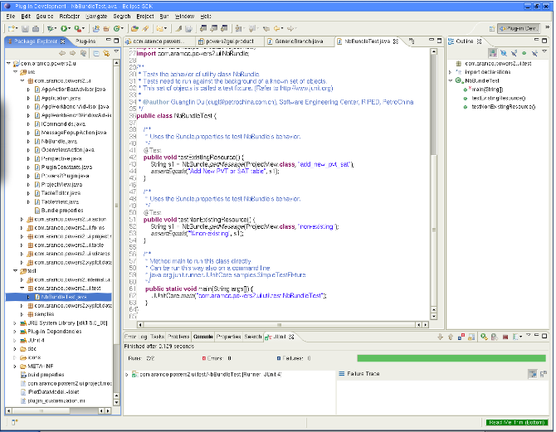

Eclipse Platform

The Eclipse Platform provides the core frameworks and services upon which all plug-in extensions are created. It also provides the runtime in which plug-ins are loaded, integrated, and executed. The primary purpose of the Platform is to enable other tool developers to easily build and deliver integrated tools.

Features include:

* Supports the construction of a variety of tools for application development
* Supports an unrestricted set of tool providers, including independent software vendors (ISVs)
* Supports tools to manipulate arbitrary content types (e.g., HTML, Java, C, JSP, EJB, XML, and GIF)
* Facilitates seamless integration of tools within and across different content types and tool providers
* Supports both GUI and non-GUI-based application development environments

Java Development Tools (JDT)

The JDT project provides the tool plug-ins that implement a Java IDE supporting the development of any Java application, including Eclipse plug-ins. It adds a Java project nature and Java perspective to the Eclipse Workbench as well as a number of views, editors, wizards, builders, and code merging and refactoring tools. The JDT project allows Eclipse to be a development environment for itself.

**Features include:**

**1.Java Projects with Source Files Arranged in Package Directories:** - This refers to the organization of Java projects, where source files are structured in package directories. This is a standard practice to manage and categorize code.

**2. Editing with Keyword and Syntax Coloring:** - Code editors provide syntax highlighting, where keywords and syntax elements are displayed in different colors. This helps developers visually distinguish between different parts of the code.

**3. Outline Showing Declaration Structure:** - An outline view displays the structure of the code, including classes, methods, and other elements. It provides a quick overview and allows for easy navigation within the code.

**4. Code Formatter:** - A code formatter automatically formats code according to predefined coding conventions. This ensures consistency in code style across the project.

5. **Refactoring**: - Refactoring tools allow developers to restructure code without changing its behavior. This includes operations like renaming variables, extracting methods, or changing the structure of classes.

**6. Search:** - Search functionality enables developers to find specific code snippets or files within a project. It is essential for efficient code navigation.

**7. Compare:** - Code comparison tools help identify differences between two sets of code. This is useful for reviewing changes, resolving conflicts, or understanding code modifications over time.

**8. Compile - JCK-Compliant Java Compiler:** - A Java compiler that adheres to the Java Compatibility Kit (JCK) ensures that compiled code is compatible with the Java platform specifications.

**9. Run Java Programs in a Separate Target Java Virtual Machine:** - The ability to run Java programs in a separate Java Virtual Machine (JVM) allows for isolated execution and testing of code.

**10. Debug Programs with JPDA-Compliant Java Virtual Machine:** - Debugging tools compatible with the Java Platform Debugger Architecture (JPDA) enable developers to identify and fix issues in their code by stepping through it and inspecting variables.These features contribute to a robust development environment, enhancing the productivity and efficiency of Java developers.

### Android Source Code

### 1. Access the Eclipse Update Manager:

### - Open Eclipse IDE.

### - Navigate to the "Help" menu.

### 2. Install Plugins:

### - Within the "Help" menu, you might find an option like "Install New Software" or "Eclipse Marketplace."

### - Click on the appropriate option to access the plugin installation interface.

### 3. Add Plugin Source:

### - You may need to add a source repository URL for Haris Peco's plugins.

### - This URL is typically provided by the plugin author or can be obtained from official documentation.

### 4. Select and Install Plugins:

### - Once the repository is added, select the plugins you want to install.

### - In this case, you are looking for plugins that provide access to the Android source code.

### 5. Follow Installation Wizard:

### - Follow the on-screen instructions in the installation wizard.

### - Accept any terms and conditions.

### 6. Restart Eclipse:

### - After the installation is complete, you might be prompted to restart Eclipse to apply the changes.

### It's important to note that the specific steps can vary based on the Eclipse version and the plugins being used. Additionally, since the information provided is a bit vague, I recommend checking Haris Peco's documentation or the Eclipse documentation for more detailed and accurate instructions on installing the plugins you need.

## Create an Android Emulator Device

Your description is accurate. Let's break down the key points:

**1. Android Emulator:**

- The Android tools provide an emulator that simulates the behavior of a real Android device.

- This emulator allows developers to test their applications without needing a physical Android device.

**2. Emulator Functionality:**

- The emulator replicates the behavior of a real Android device in most cases.

- Developers can use it to interact with and test their applications as if they were running on an actual device.

**3. Testing without a Real Device:**

- The primary purpose of the emulator is to enable testing without the need for a physical Android device.

- This is particularly useful during the development and testing phases of an Android application.

**4. Configuration via AVD:**

- Each configuration for the emulator is defined through an "Android Virtual Device" (AVD).

- AVDs allow developers to specify various parameters such as device type, screen size, Android version, and other hardware characteristics.

**5. Multiple Configurations:**

- Developers can emulate one or several devices with different configurations simultaneously.

- This flexibility helps in testing applications under various scenarios and device specifications.

The Android Emulator is a valuable tool for Android developers, providing a convenient way to test applications across different device configurations without the need for physical devices. AVDs offer a way to customize the emulation environment to match specific testing requirements.

To define an AVD press the device manager button, press "New" and maintain the following.

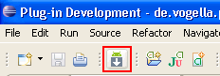

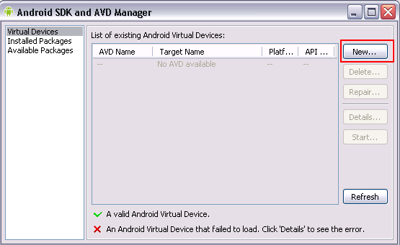

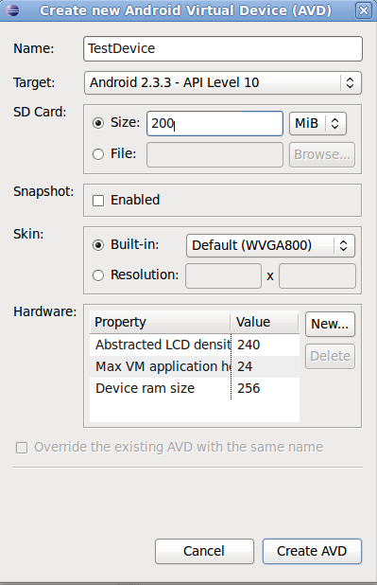

Press "Create AVD". This will create the device and display it under the "Virtual devices". To test if your setup is correct, select your device and press "Start".



## 4. Error handling

Things are not always working as they should be. Several users report that get the following errors:

**Error: Project ... is missing required source folder: 'gen'**

* + This error suggests that the 'gen' folder, which typically contains generated files, is missing from the project.

**Error: The project could not be built until build path errors are resolved.**

**SYSTEM STUDY**

**FEASIBILITY STUDY**

The feasibility of the project is analyzed in this phase and business proposal is put forth with a very general plan for the project and some cost estimates. During system analysis the feasibility study of the proposed system is to be carried out. This is to ensure that the proposed system is not a burden to the company. For feasibility analysis, some understanding of the major requirements for the system is essential.

Three key considerations involved in the feasibility analysis are

* ECONOMICAL FEASIBILITY
* TECHNICAL FEASIBILITY
* SOCIAL FEASIBILITY

**ECONOMICAL FEASIBILITY**

Your description emphasizes the economic feasibility study for a system, highlighting the importance of assessing the economic impact and justifying expenditures. Let's break down the key points:

**1. **Economic Feasibility Study:\*\***

- The study is conducted to check the economic impact of the system on the organization.

**2. **Limited Research and Development Funds:\*\***

- The organization has limited funds available for research and development of the system.

**3. **Expenditure Justification:\*\***

- Expenditures associated with the system must be justified.

- The economic feasibility study ensures that the costs are reasonable and justifiable.

**4. **Budget Alignment:\*\***

- The developed system must align with the budget constraints of the organization.

- Staying within budget is crucial for economic viability.

**5. **Utilization of Freely Available Technologies:\*\***

- The system was developed within budget constraints by utilizing freely available technologies.

- This approach minimizes costs associated with technology acquisition.

**6. Customized Product Purchases:**

- Only customized products needed for the system had to be purchased.

- This strategic approach helps control costs and ensures targeted investments.

Assessing economic feasibility is essential to ensure that the organization can afford the development and implementation of the system. The study focuses on making informed decisions about resource allocation, cost-effectiveness, and justifying expenditures within the available budget. Utilizing freely available technologies and selectively purchasing customized products contribute to cost control and economic viability.

**TECHNICAL FEASIBILITY**

**1. Technical Feasibility Study:**

- The study is conducted to check the technical feasibility of the system.

**2. Technical Requirements:**

- The focus is on evaluating the technical requirements of the system.

- Technical requirements include aspects such as hardware, software, and other technical components.

**3. Resource Demands:**

- The system developed should not impose a high demand on available technical resources.

- Excessive demands on resources could lead to challenges and limitations for the client.

**4. Modest Requirements:**

- It is essential for the developed system to have modest technical requirements.

- Minimal or no changes should be required to implement the system, ensuring practicality and efficiency.

**5. Impact on the Client:**

- High demands on technical resources could adversely impact the client.

- The goal is to develop a system that aligns with available resources and does not strain the client's capabilities.

Assessing technical feasibility is a critical step in the early stages of system development. It ensures that the proposed system can be implemented without imposing excessive technical demands or requiring significant changes. A system with modest technical requirements is more likely to be practical, cost-effective, and feasible for implementation within the existing technical infrastructure.

**SOCIAL FEASIBILITY**

**1. User Acceptance Study:**

- The study aims to assess the level of acceptance of the system by users.

**2. User Training:**

- Training users to use the system efficiently is a crucial aspect.

- Proper training ensures that users are equipped with the knowledge and skills needed to interact with the system effectively.

**3. User Perception:**

- Users should not feel threatened by the system; instead, they should perceive it as a necessity.

- Building a positive perception helps in fostering user acceptance.

**4. Methods for User Education:**

- The level of acceptance depends on the methods employed to educate users about the system.

- Effective educational methods contribute to user familiarity and confidence.

**5. User Confidence:**

- User confidence is a key factor in determining system acceptance.

- Raising user confidence ensures that users feel comfortable and capable when using the system.

**6. Constructive Criticism:**

- Users should feel encouraged to provide constructive criticism.

- Constructive feedback from users is valuable for improving the system and addressing any concerns they may have.

**7. User as the Final User:**

- Users are the final users of the system, and their acceptance is pivotal.

- Considering the user's perspective and addressing their needs contributes to overall system success.

In summary, the success of a system is closely tied to user acceptance. Providing effective training, building user confidence, and creating an environment where users feel comfortable expressing constructive criticism are essential elements in ensuring that the system meets user expectations and is embraced by its intended audience.

**SYSTEM TESTING**

Your description of the purpose of testing is accurate. Let's break down the key points:

**1. Purpose of Testing:**

- The primary purpose of testing is to discover errors in a work product.

- Testing involves the process of attempting to identify every conceivable fault or weakness in the software.

**2. Scope of Testing:**

- Testing is applied at various levels, including components, sub-assemblies, assemblies, and finished products.

- It checks the functionality of these elements to ensure they meet requirements and user expectations.

**3. Definition of Testing:**

- Testing is defined as the process of exercising software with the intent of ensuring that the software system:

- Meets its specified requirements.

- Meets user expectations.

- Does not fail in an unacceptable manner.

**4. Exercising Software:**

- The process of testing involves actively exercising the software, subjecting it to various inputs and scenarios to assess its behavior.

**5. Testing Requirements:**

- Different types of tests address specific testing requirements.

- Each test type is designed to fulfill a particular objective in the testing process.

Testing is a critical phase in the software development lifecycle, providing assurance that the software meets quality standards, functions as intended, and satisfies user expectations. The diversity of test types allows for a comprehensive evaluation of different aspects of the software, including functionality, performance, security, and reliability. Through systematic testing, potential errors are identified and addressed, contributing to the overall quality and reliability of the software product.

**TYPES OF TESTS**

**UNIT TESTING**

Your description of unit testing is accurate. Let's break down the key points:

**1. Definition of Unit Testing:**

- Unit testing involves the design of test cases to validate that the internal program logic functions correctly.

- It verifies that program inputs produce valid outputs and that decision branches and internal code flow are validated.

**2. Focus on Individual Software Units:**

- Unit testing is the testing of individual software units of the application.

- It is conducted after the completion of an individual unit before integration, ensuring that each unit works as intended in isolation.

**3. Structural Testing:**

- Unit testing is a form of structural testing that relies on knowledge of the internal construction of the software.

- It is considered invasive as it involves testing the internal logic and components of the code.

**4. Performed at the Component Level:**

- Unit tests perform basic tests at the component level, validating specific business processes, applications, or system configurations.

- The focus is on testing individual units of code, such as functions, methods, or modules.

**5. Verification of Business Process Accuracy:** - Unit tests ensure that each unique path of a business process performs accurately according to documented specifications.

- Clear inputs and expected results are defined for each unit test, allowing for precise verification of the unit's behavior.

Unit testing plays a crucial role in the software development process by validating the correctness of individual units of code. It provides early feedback to developers, helps identify and fix defects at an early stage, and contributes to the overall reliability and maintainability of the software. The focus on specific units allows for targeted testing, ensuring that each component works as intended before integration with other units.

**INTEGRATION TESTING**

Your description of integration testing is accurate. Let's break down the key points:

**1. Definition of Integration Testing:**

- Integration testing is designed to test integrated software components to determine if they operate cohesively as one program when combined.

- The focus is on evaluating the interactions and interfaces between different components.

**2. Event-Driven Testing:**

- Integration testing is event-driven, meaning that tests are designed to respond to specific events or interactions between integrated components.

- The testing is concerned with the basic outcomes of screens or fields, assessing how integrated components behave in response to events.

**3. Outcome of Screens or Fields:**

- The testing places emphasis on assessing the basic outcomes of screens or fields, ensuring that the integrated components produce the expected results when combined.

**4. Validation of Unit Testing Results:**

- Integration tests demonstrate that, although the individual components were independently satisfactory in unit testing, the combination of components is correct and consistent.

- It verifies that the components work harmoniously together in a real-world scenario.

**5. Exposing Problems from Component Combination:**

- Integration testing is specifically aimed at exposing problems that arise from the combination of components.

- It helps identify issues related to data flow, communication, and compatibility when components are integrated.

Integration testing is a crucial step in the software testing process, ensuring that the integrated components of a software application function seamlessly together. By focusing on the combined behavior of components, integration testing helps uncover potential issues that may arise only when different modules or units interact. This contributes to the overall reliability and stability of the software in a real-world environment.

**FUNCTIONAL TEST**

Your description of functional testing is comprehensive. Let's break down the key points:

**1. Definition of Functional Testing:** - Functional testing involves systematic demonstrations to ensure that functions tested are available as specified by business and technical requirements, system documentation, and user manuals.

**2. Centrality of Functional Testing:**

- Functional testing is centered on specific items, including valid input, invalid input, Functions, output, and interfacing systems or procedures.

**3. Key Aspects of Functional Testing:**

- **Valid Input**: Ensures that identified classes of valid input are accepted by the system.

- **Invalid Inpu**t: Verifies that identified classes of invalid input are rejected by the system.

- **Functions**: Focuses on exercising identified functions within the software.

- **Output**: Exercises identified classes of application outputs to validate correctness.

- **Systems**: Verifies that interfacing systems or procedures are invoked and function correctly.

**4. Organization and Preparation of Functional Tests:**

- The organization and preparation of functional tests are focused on requirements, key functions, or special test cases.

- Systematic coverage is essential, considering business process flows, data fields, predefined processes, and successive processes for testing.

**5. Additional Tests and Systematic Coverage:**

- Before functional testing is complete, additional tests are identified to ensure comprehensive coverage.

- The effectiveness of current tests is determined, and adjustments are made as needed to enhance coverage and identify any gaps.

Functional testing plays a crucial role in ensuring that the software meets specified requirements and functions as intended in various scenarios. It provides a systematic approach to validate the functionality of the software application, covering a range of inputs, outputs, and system interactions. The emphasis on systematic coverage and continuous refinement of tests contributes to the thoroughness and effectiveness of the testing process.

**SYSTEM TEST**

Your description of system testing is accurate. Let's break down the key points:

**1. Definition of System Testing:**

- System Testing is a level of software testing that evaluates the entire integrated software system to ensure that it meets specified requirements and functions as intended.

**2. Scope and Integration:**

- The focus of system testing is on the entire software system as a whole, testing the interactions between its components and ensuring that all integrated parts work seamlessly together.

- Integration points and process links are emphasized during system testing to verify the integration of different modules or components.

**3. Configuration-Oriented System Integration Test:**

- An example provided is the configuration-oriented system integration test, where the system is tested with various configurations to ensure known and predictable results.

- This approach helps identify any issues related to different configurations of the software.

**4. Verification of Process Descriptions and Flows:**

- System testing is based on process descriptions and flows, verifying that the processes within the system operate according to predefined specifications.

- The emphasis is on testing the end-to-end functionality of the system, including how different processes interact with each other.

**5. Pre-Driven Process Links:**

- The testing approach involves pre-driven process links, meaning that the testing scenarios and cases are designed based on the anticipated process flows within the system.

- This ensures that the testing aligns with the expected behavior of the system under normal and exceptional conditions.

**6. Ensuring Known and Predictable Results:**

- System testing aims to ensure that the results of testing are known and predictable. By testing the entire system, including its various components and interactions, the testing team aims to identify and resolve any issues that may arise.

**7. Comprehensive Validation:**

- System testing provides comprehensive validation of the entire software system before it is released to users. This is a critical step to ensure that the system meets user requirements and performs reliably in a real-world environment.

In summary, system testing is a crucial phase in the software testing process, focusing on the integration and functionality of the entire software system. It provides a holistic evaluation to ensure that the system behaves as expected and meets the specified requirements.**WHITE BOX TESTING**

Your description of White Box Testing is accurate. Let's delve into the key points:

**1. Definition of White Box Testing:**

- White Box Testing is a software testing approach where the tester possesses knowledge of the internal workings, structure, code, and language of the software being tested.

- Testers have visibility into the internal components, algorithms, and logic of the software.

**2. Testing with Knowledge of Internal Structure:**

- White Box Testing involves testing the internal logic, code paths, and structures of the software application. Testers have insights into how the software is designed and implemented.

**3. Understanding the Inner Workings:**

- Testers conducting White Box Testing are aware of the internal details, including data structures, variables, and the flow of control within the software.

- Knowledge of the programming language, design patterns, and architecture is leveraged during testing.

**4. Testing Unreachable Areas from Black Box Level:**

- White Box Testing is utilized to test areas of the software that may not be reachable or thoroughly testable from a black box testing perspective.

- It allows testers to examine specific code branches, conditions, and execution paths that may be critical for ensuring comprehensive test coverage.

**5. Verification of Internal Components:**

- Verification of internal components, such as functions, procedures, classes, and modules, is a key focus of White Box Testing.

- The goal is to ensure that each internal component functions as intended and contributes to the overall correctness of the software.

**6. Code-Level Testing Techniques:**

- White Box Testing employs various code-level testing techniques, including statement coverage, branch coverage, path coverage, and other metrics to assess the thoroughness of testing.

**7. Developer and Tester Collaboration:**

- White Box Testing often involves collaboration between developers and testers, as the testers need a deep understanding of the codebase.

While Black Box Testing assesses the software from an external, user-centric perspective, White Box Testing provides an in-depth examination of the internal structures and logic. Both testing approaches are valuable components of a comprehensive testing strategy, each addressing different aspects of software quality.

**BLACK BOX TESTING**

Your description of Black Box Testing is accurate. Let's break down the key points:

**1. Definition of Black Box Testing:**

- Black Box Testing is a software testing method where the tester evaluates the functionality of a software application without having detailed knowledge of its internal code, structure, or implementation details.

- The term "black box" metaphorically represents the software as an opaque entity, and the tester interacts with it without knowledge of its internal workings.

**2. Testing Without Internal Knowledge:**

- Testers perform Black Box Testing without access to the source code, algorithms, or any understanding of the internal logic of the software module being tested.

- The focus is solely on the software's inputs, expected outputs, and the observed behavior without delving into the internal mechanisms.

**3. Source Documentation for Test Design:**

- Black Box tests are designed based on external specifications or requirements documents. Testers use these definitive sources to create test cases, ensuring that the testing aligns with the expected functionality outlined in the documentation.

**4. Treats Software as a "Black Box":**

- The software under test is treated as a "black box" where the tester interacts with the input and observes the output, but the internal processes are not considered or examined.

- Testers do not have knowledge of the internal data structures, algorithms, or code paths.

**5. Focus on Inputs and Outputs:**

- Black Box Testing focuses on providing inputs to the software and validating the corresponding outputs. The goal is to ensure that the software behaves as expected based on the specified requirements.

**6. Promotes Independence:**

- Black Box Testing promotes independence between the development and testing teams. Testers do not need to be familiar with the programming language or the internal design, allowing for an unbiased assessment of the software's functional capabilities.

Overall, Black Box Testing is valuable for validating the external behavior and functionality of software applications, helping identify discrepancies between expected and actual outcomes without requiring knowledge of the internal implementation details.**UNIT TESTING:**

Unit testing is a critical aspect of the software development lifecycle, focusing on testing individual units or components of a software application in isolation. Your statement accurately reflects that unit testing is typically conducted in conjunction with the coding phase, and both may be combined into a unified phase or treated as separate activities. Let's elaborate on each scenario:

**1. Combined Code and Unit Test Phase:**

- In this approach, developers write code for specific units or components, and as part of the same phase, they also perform unit testing on those components. The objective is to ensure that each unit behaves as expected in isolation before integrating it into the larger system. This integrated approach promotes an iterative and test-driven development process.

**2. Distinct Coding and Unit Testing Phases:**

- Alternatively, coding and unit testing may be treated as distinct phases. Developers complete the coding phase, and then the unit testing phase follows separately. This allows developers to focus initially on code implementation, and once units are coded, dedicated attention is given to verifying the correctness of each unit through testing.

The choice between these approaches often depends on the development methodology, project requirements, and team preferences. Agile methodologies, for example, often emphasize continuous integration and testing, leading to a combined approach. In contrast, more traditional or waterfall methodologies may involve distinct phases.

Regardless of the chosen approach, the key is to ensure that thorough unit testing is conducted to validate the correctness of individual units. Unit testing helps catch defects early in the development process, promoting a higher level of software quality and facilitating easier identification and resolution of issues.

**Test strategy and approach**

Certainly, let's break down the key aspects of the approach involving manual field testing and detailed functional test cases:

**1. Manual Field Testing:**

- **Hands-On Interaction:** Manual field testing involves hands-on interaction with the software in a real-world environment. Testers actively use the application as end-users would, exploring various features and functionalities.

- **Real-World Scenarios:** Testers simulate real-world scenarios to ensure that the software performs as expected in diverse conditions. This includes testing in different environments, network conditions, and user scenarios.

**2. Detailed Functional Test Cases:**

- **Step-by-Step Instructions:** Detailed functional test cases provide step-by-step instructions for executing specific functionalities of the application. Each test case is carefully documented to cover different aspects of the software.

- **Test Coverage:** Functional test cases aim to achieve comprehensive test coverage, addressing positive and negative scenarios, boundary conditions, and potential error paths.

- **Reproducibility:** Well-documented test cases ensure the reproducibility of test scenarios, allowing consistency in testing across multiple iterations and environments.

**3. Benefits of the Approach:**

- **User-Centric Testing:** Manual field testing provides a user-centric perspective, allowing testers to assess usability, user interface interactions, and overall user experience.

- **Exploratory Testing:** Testers have the flexibility to perform exploratory testing, uncovering issues that may not be explicitly covered by scripted test cases.

- **Adaptability:** Manual testing is adaptable to changes and allows testers to respond to evolving conditions during testing, mimicking the unpredictability of real-world usage.

**4. Considerations for Test Automation:**

- While manual testing is essential, considering test automation for repetitive and regression testing can enhance efficiency and coverage.

- Automation is particularly beneficial for scenarios where tests need to be executed frequently, ensuring rapid feedback on software changes.

In summary, the combination of manual field testing with detailed functional test cases is a robust approach that captures the real-world aspects of software usage. The strategy allows for a thorough examination of functionalities, user interactions, and overall software performance. Balancing manual testing with automation, where applicable, contributes to a comprehensive and effective testing process.:

**1. Field Testing:**

- **Manual Execution:** Field testing involves hands-on, manual execution of test scenarios in a real-world environment. Testers interact with the application as end-users would, examining how it behaves under different conditions.

- **Real-world Scenarios:** Field testing often simulates real-world usage, ensuring that the software functions as expected in diverse environments and situations.

2. **Functional Tests:**

- **Detailed Test Cases:** Functional tests are written in detail, providing step-by-step instructions on how to verify specific functionalities of the application.

- **Test Coverage:** Detailed functional tests aim to cover various aspects of the software, including positive and negative scenarios, edge cases, and different input combinations.

- **Reproducibility:** Well-documented functional tests facilitate the reproducibility of test scenarios, enabling consistency in testing across different cycles.

Benefits of Manual Field Testing with Detailed Functional Tests:

- **User Perspective:** Manual field testing allows testers to assess the application from the user's perspective, identifying potential usability issues, and ensuring a positive user experience.

- **Exploratory Testing:** Manual testing allows for exploratory testing, where testers can uncover unforeseen issues that might not be covered by scripted test cases.

- **Adaptability:** Testers can adapt to changing conditions during manual testing, mimicking the unpredictable nature of real-world usage.

While manual field testing with detailed functional tests is valuable, it's also essential to consider test automation, especially for repetitive and regression testing. Automation can enhance testing efficiency and coverage, allowing testers to focus on more complex and exploratory aspects of testing. The optimal testing strategy often combines both manual and automated testing approaches based on the specific needs and characteristics of the project.

**Test objectives**

Certainly, let's elaborate further on the specified requirements:

**1. All field entries must work properly:**

- This requirement ensures the proper functionality of all input fields within the application. It includes validating that users can input data into fields without encountering errors, and the system accurately processes and stores the entered information. Testing scenarios should encompass a range of data types, edge cases, and valid/invalid inputs to thoroughly assess field behavior.

**2. Pages must be activated from the identified link:**

- This criterion emphasizes the correct navigation within the application. When users interact with links or navigate through the interface, it is crucial that the associated pages or functionalities are activated as intended. Testing scenarios should cover various links, buttons, and navigation paths to ensure accurate page activations.

**3. The entry screen, messages, and responses must not be delayed:**

- This requirement addresses the responsiveness and performance of the application. Users expect prompt responses from the system, including entry screen loading, messages, and overall system responses. Testing should evaluate the system's speed under different conditions, ensuring it meets acceptable performance standards and delivers a seamless user experience.

In summary, each requirement targets a specific aspect of the application's functionality, usability, and performance. Elaborate testing strategies, including positive and negative test cases, can be designed to rigorously assess the application against these criteria. Regular testing, including regression testing as the application evolves, is essential to maintain a high-quality user experience and ensure that the specified requirements continue to be met.

**1. All field entries must work properly:**

**-** This requirement emphasizes the proper functioning of all input fields within the application. It includes validating that users can enter data into fields without encountering errors, and the system accurately processes and stores the entered information. Testing scenarios should cover a variety of data types and ensure that all fields behave as intended.

**2. **Pages must be activated from the identified link:\*\***

**-** This criterion focuses on the correct navigation within the application. When users click on a link or navigate through the interface, the corresponding pages should be activated as expected. Testing should confirm that links are correctly associated with their designated pages or functionalities, ensuring a seamless user experience.

**3. **The entry screen, messages, and responses must not be delayed:\*\***

**-** This requirement addresses the responsiveness and performance of the application. Entry screens, messages, and system responses should be delivered promptly without noticeable delays. This involves assessing the system's speed, efficiency, and overall responsiveness under various conditions, such as different user loads or network speeds.

To verify these criteria, a combination of manual and automated testing approaches can be employed.

**Features to be tested**

* The mentioned verification criteria for a system or application involve specific checks to ensure data accuracy, uniqueness, and proper functionality. Let's break down each requirement:
* 1. **Verify that the entries are of the correct format:**
* - This involves checking that the data entered adheres to the specified format. For example, if a date field is expected in the format "MM/DD/YYYY," the system should verify that users enter dates in this format. This ensures data consistency and validity.
* 2. **No duplicate entries should be allowed:**
* - The system should have mechanisms in place to identify and prevent the input of duplicate data. This can be essential for maintaining data integrity and avoiding redundancy. For instance, if users are entering email addresses, the system should validate that each email address is unique.
* 3. **All links should take the user to the correct page:**
* - This requirement pertains to the proper functioning of hyperlinks or navigation elements within the system. When users click on a link, it should lead them to the intended destination or page. Regular testing and validation of links ensure a smooth and accurate user experience.
* INTEGRATION TESTINGSS

Software integration testing is a phase of testing that involves the incremental integration of two or more software components on a single platform. The primary objective of integration testing is to identify and address failures that may arise due to interface defects between the integrated components.

Key points about software integration testing include:

1. **Incremental Integration:**

- Integration testing is conducted in an incremental manner, where individual software components are combined and tested step by step to ensure proper interaction.

2. **Single Platform:**

- The integrated components are tested on a single platform to uncover any issues related to how they interact with each other.

3. **Identification of Interface Defects:**

- The main focus of integration testing is to discover and rectify defects or errors that may occur at the interfaces between the integrated components. This includes issues such as data passing, communication, and interaction protocols.

4. **Components or Applications Interaction:**

- Integration testing is concerned with checking the interaction between components within a software system or, on a broader scale, the interaction between software applications at the organizational level.

5. **Error-Free Interaction:**

- The goal is to verify that the components or applications interact seamlessly without errors, ensuring the overall reliability and functionality of the integrated software.

6. **Task of Integration Test:**

- The task of integration testing is to confirm that the integrated components or applications, which could be at various levels of a software system, work together without encountering errors.

**ACCEPTANCE TESTING**

Absolutely, User Acceptance Testing (UAT) is a crucial phase in the project lifecycle where the end users play a pivotal role. This testing phase is designed to ensure that the system meets the functional requirements and is ready for deployment. Key aspects of User Acceptance Testing include:

1. **End User Involvement:**

- UAT involves active participation from end users who will be using the system in real-world scenarios. Their involvement is crucial in validating whether the system aligns with their needs and expectations.

2. **Functional Requirement Verification:**

- The primary goal of UAT is to verify that the system meets the specified functional requirements. End users assess the system's functionality, features, and overall performance against the documented requirements.

3. **Real-World Testing:**

- UAT simulates real-world scenarios to ensure that the system functions as intended in practical usage. This includes testing different workflows, scenarios, and user interactions to uncover any potential issues.

4. **Identification of Defects or Gaps:**

- If any discrepancies, defects, or gaps are identified during UAT, they are reported, and the development team addresses them before final deployment.

5. **User Feedback and Approval:**

- End users provide feedback on their experience with the system during UAT. Based on this feedback, decisions are made regarding system approval for deployment.

6. **User Training Validation:**

- UAT validates that any training provided to end users is effective, ensuring that users can navigate and use the system confidently.Successful completion of User Acceptance Testing is a critical milestone as it signifies that the system is ready for production release and has been validated by the actual users who will rely on it for their day-to-day activities

**Conclusion:**

Home care is a crucial health strategy, holding significance both from an economic standpoint to prevent hospitalization and from a social perspective to sustain patients by providing treatment and quality care. Despite its advantages, the mobile nature of home care services poses challenges in terms of providing resources comparable to those available in hospitals. This includes challenges related to computational and software resources, as well as concentrated attention from healthcare providers.

One notable feature of home care services is the ability for users to schedule appointments with doctors based on the doctor's availability. This empowers patients to receive necessary medical attention in the comfort of their homes, enhancing convenience and potentially reducing the need for hospital visits. However, ensuring that home care services can deliver resources equivalent to those found in hospitals remains a challenge that involves addressing issues related to technology, software, and personalized attention.

**TESTING RESULTS**

**TESTING CASES**

|  |  |  |  |  |  |  |  |
| --- | --- | --- | --- | --- | --- | --- | --- |
| Test case id | Test Scenario | Test Steps | Prerequisites | Test Data | Expected result | Actual result | Test status |
| **#CVD001** | To authenticate a successful signup with user data | * User navigate the signup page * Enter the valid user data * Click on signup button | User data | Username  Password  Mobile  Email  location | When the user submits the user data, data should be store in database successfully | As Expected, | Pass |
| **#CVD002** | To authenticate a successful login with user data | * User navigate the login page. * Enter the valid username, password. * Click on login button | Username, password | Username password | When the user submits the user data, data should be authenticated successfully | As Expected, | Pass |